

**Society-360 (Society Management System)**

**By**

**Student Name : Suhas Shankar Gondukupi**

**Roll No : 25317**

**Under The Guidance of**

**Prof. Urmila Kadam**

**MCA-I (SEM-I)**

**2025-26**



**Date: 24/12/2025**

**Certificate**

This is to certify that **Suhas Shankar Gondukupi**, Roll No. **25317** a student of **Dr D Y Patil School of MCA**, has successfully completed the project entitled **Society 360: A Society Management System** in partial fulfilment of the requirements for the MCA- Mini Project (Semester I) during the academic year **2025–2026**.

|  |  |  |
| --- | --- | --- |
| Prof. Urmila Kadam | Prof. Sapna Chavan | Dr. E.B. Khedkar |
| **Project Guide** | **HOD - MCA** | **Director** |

**ACKNOWLEDGEMENT**

I acknowledge to all those who have been so helpful in my academic project work. Nevertheless, I have tried through this report to express my deepest gratitude to all those who have given their precious time, skill, knowledge, valuable advice and guidance and facilities.

At the very outset I take opportunity to express my deepest gratitude and thanks to **Director** of our College **Dr. E. B. Khedkar** and **Prof. Sapna Chavan–HOD** and other teaching and non- teaching staff for their useful guidance during the completion of this project report.

I am highly obliged to **Prof. Urmila Kadam** - Project Guide - for her valuable guidance and encouragement given to complete the project. His guidance has certainly helped me to simplify the difficulties and finalize the system effectively.

Last but not the least I thank to my almighty God, Parents and friends for their constant support to me in all aspects during work.

**Thank You,**

Suhas Shankar Gondukupi

MCA – I (Sem-I)

Dr D Y Patil School of MCA

**INDEX**

|  |  |  |
| --- | --- | --- |
| Sr. No. | Title | Page No. |
| **1** | **Chapter 1: Introduction** | 5 |
| 1.1 | Abstract |  |
| 1.2 | Existing System and Need for System |  |
| 1.3 | Scope of System |  |
| 1.4 | Operating Environment - Hardware and Software |  |
|  | Brief Description of Technology Used |  |
| 1.5 | Operating systems used (Windows or Unix), RDBMS/No SQL used to build database |  |
| 1.5.1 | Operating systems used (Windows or Unix) |  |
| **2** | **Chapter 2: Proposed System** |  |
| 2.1 | Feasibility Study |  |
| 2.2 | Objectives of Proposed System |  |
| 2.3 | Users of System |  |
| **3** | **Chapter 3: Analysis and Design** |  |
| 3.1 | System Requirements (Functional and Non-Functional) |  |
| 3.2 | Entity Relationship Diagram (ERD) |  |
| 3.3 | Table Structure |  |
| 3.4 | Use Case Diagrams |  |
| 3.5 | Class Diagram |  |
| 3.6 | Activity Diagram |  |
| 3.7 | Sequence Diagram |  |
| 3.8 | Deployment Diagram & Module Hierarchy Diagram |  |
| 3.9 | Sample Input and Output Screens |  |
| **4** | **Coding** |  |
| 4.1 | Algorithms |  |
| 4.2 | Code Snippets |  |
| **5** | **Testing** |  |
| 5.1 | Test Strategy |  |
| 5.2 | Unit Test Plan |  |
| 5.3 | Acceptance Test Plan |  |
| 5.4 | Test Case / Test Script |  |
| 5.5 | Defect Report / Test Log |  |
| **6** | **Limitations of Proposed System** |  |
| **7** | **Proposed Enhancements** |  |
| **8** | **Conclusion** |  |
| **9** | **Bibliography** |  |

**Chapter 1: Introduction**

**1.1 Abstract**

Society 360 is a web-based society management system designed to streamline residential community operations. The system provides a centralized platform for property owners and administrative staff to manage notices, maintenance payments, amenity bookings, and complaint resolution. Built using Django and MySQL, the application implements role-based access control, secure payment processing via Razorpay integration, and automated email notifications to reduce manual intervention and improve operational transparency.

**1.2 Existing System and Need for System**

**Existing System Limitations**

Current residential society management typically relies on:

* Physical notice boards and manual circular distribution
* Cash/check-based maintenance payment collection requiring in-person handling
* Paper-based or spreadsheet-managed amenity booking systems
* Unstructured complaint submission (verbal, WhatsApp, paper slips)
* Fragmented communication channels leading to information asymmetry
* No centralized audit trail for financial transactions or administrative actions

**Need for Society 360**

The system addresses critical gaps in current practices:

* **Centralized Communication**: Digital notice board with guaranteed delivery via email notifications
* **Automated Payment Processing**: Online maintenance payments with integrated receipt generation and tracking
* **Transparent Amenity Management**: Real-time booking system with conflict prevention
* **Structured Complaint Resolution**: Formalized ticketing system with status tracking
* **Operational Transparency**: Complete audit trails for all administrative actions and financial transactions

**1.3 Scope of System**

* User authentication and role-based access control for owners and administrators
* Digital notice management with creation, publication, and archiving capabilities
* Online maintenance payment processing with Razorpay integration
* Amenity reservation system with availability checking and scheduling
* Complaint management workflow from submission to resolution tracking
* Automated email notifications for system events (payments, bookings, notices)
* Administrative dashboard for monitoring all system activities
* MySQL database for persistent storage of all system data

**1.4 Operating Environment**

**Development Environment:**

* Processor: Intel Core i5 or equivalent, 2.0 GHz minimum
* RAM: 8 GB minimum, 16 GB recommended
* Storage: 10 GB available disk space
* Network: Broadband internet connection for payment gateway integration

**Software Requirements**

**Client-Side:**

* Web Browser: Chrome 80+, Firefox 75+, Safari 13+, Edge 80+
* JavaScript enabled
* Responsive design support for mobile/tablet browsers

**Server-Side:**

* Python 3.11+
* Django 5.0+
* MySQL 8.0+
* Web Server: WSGI
* SMTP server for email notifications

**1.5 Technology Stack**

**Operating System**

* **Development**: Windows 11
* **Production**: Linux (Ubuntu 22.04 LTS) recommended for stability and security updates

**Database Management System**

* **Primary Database**: MySQL 8.0+ (Relational Database Management System)
* **Rationale**:
  + ACID compliance for financial transactions
  + Native integration with Django via MySQL connector
  + Support for complex queries across user, payment, and complaint tables

**Database Schema Components**

1. **auth_user**: Extended Django authentication model for owner/admin roles
2. **notices**: Notice publication with metadata (priority, expiration, audience)
3. **payments**: Maintenance payment records with transaction status and gateway references
4. **amenities**: Amenity definitions with capacity, scheduling rules, and booking constraints
5. **bookings**: Reservation records with time slots and confirmation status
6. **complaints**: Ticket system with priority, status, and resolution tracking

**Brief Description of Technology Used**

* **Frontend**: HTML5, CSS3, JavaScript with Bootstrap 5 for responsive design
* **Backend Framework**: Django (Python) for rapid development with built-in admin interface and security features
* **Payment Integration**: Razorpay API for PCI DSS compliant payment processing
* **Email Service**: Django's SMTP backend with templated email generation
* **Version Control**: Git for source code management

**Chapter 2: Proposed System**

**2.1 Feasibility Study**

**A. Technical Feasibility**

**Technology Stack Maturity:**

* Django (Python) is production-proven with built-in security, ORM, and admin interface
* MySQL 8.0 provides transaction support required for payment processing
* Bootstrap 5 ensures responsive design across devices
* Razorpay API offers PCI DSS compliant payment gateway integration
* All components are open-source with enterprise support options

**Integration Complexity:**

* Payment gateway integration follows documented REST API patterns
* Email notification system uses standard SMTP protocols
* Database schema is normalized but not overly complex
* No dependencies on proprietary or niche technologies

**Skill Availability:**

* Python/Django developers are widely available
* Frontend technologies (HTML/CSS/JavaScript/Bootstrap) are industry standards
* MySQL administration skills are common
* Deployment on Linux with Nginx/WSGI is well-documented

**B. Operational Feasibility**

**User Adoption:**

* Web-based interface requires no installation for end users
* Intuitive role-based interfaces reduce training requirements
* Email notifications provide familiar interaction pattern
* Mobile-responsive design accommodates smartphone usage

**Administrative Overhead:**

* Django admin interface reduces custom administrative tool development
* Automated payment processing reduces manual reconciliation work
* Centralized complaint tracking improves resolution efficiency

**Maintenance Requirements:**

* Standard LAMP stack components with established maintenance practices
* Regular security updates available for all software components
* Database backup/restore procedures are well-defined

**C. Economic Feasibility**

**Development Costs:**

* Open-source software stack eliminates licensing fees
* Development effort focused on business logic rather than infrastructure
* Razorpay transaction fees are competitive (standard payment gateway rates)

**Operational Costs:**

* Hosting on VPS or cloud instance (estimated $20-50/month for moderate society)
* SSL certificate (free via Let's Encrypt or commercial options)
* SMTP service (transactional email services or society's existing email server)
* Payment gateway fees (percentage-based on transaction volume)

**Return on Investment:**

* Reduced administrative staff time for payment collection and reconciliation
* Elimination of manual notice distribution costs
* Improved cash flow through automated payment reminders
* Increased resident satisfaction potentially leading to higher compliance rates

**D. Schedule Feasibility**

**Development Timeline:**

* Core authentication and user management: 2-3 weeks
* Notice management module: 0-1 weeks
* Payment integration: 1-2 weeks (including testing)
* Amenity booking system: 2 weeks
* Complaint management: 1 week
* Testing and deployment: 1 week
* **Total estimated development time: 9-12 weeks**

**Critical Path:**

* Payment gateway integration requires external API dependencies
* Database schema must be finalized before major development
* User acceptance testing with actual society members

**E. Legal and Compliance Feasibility**

**Data Protection:**

* Personal data storage compliant with applicable privacy regulations
* Payment data handled by PCI DSS compliant payment processor
* Secure authentication using Django's built-in password hashing

**Financial Compliance:**

* Payment records provide audit trail for financial reconciliation
* Receipt generation meets basic accounting requirements
* Transaction records include gateway references for dispute resolution

**Accessibility:**

* Web Content Accessibility Guidelines (WCAG) compliance via Bootstrap framework
* Responsive design ensures usability across devices

**2.2 Objectives of Proposed System**

**Primary Objectives**

1. **Centralize Society Operations**: Provide single platform for all society management functions
2. **Automate Payment Processing**: Eliminate manual cash/check handling through Razorpay integration
3. **Standardize Communication**: Replace physical notice boards with digital publication and email notifications
4. **Streamline Amenity Management**: Implement conflict-free reservation system with real-time availability
5. **Formalize Complaint Resolution**: Establish structured ticketing system with tracking and accountability

**Functional Objectives**

**For Property Owners:**

* Self-service portal for all resident interactions
* Secure online maintenance payment with instant confirmation
* Transparent view of society notices and announcements
* Fair access to shared amenities through booking system
* Formal channel for issue reporting with status tracking

**For Administrative Staff:**

* Centralized dashboard for monitoring all society operations
* Efficient notice distribution with delivery confirmation
* Automated payment tracking and reconciliation
* Amenity scheduling with conflict prevention
* Structured complaint management workflow

**Technical Objectives**

1. **Reliability**: 99.5% uptime target for core functionalities
2. **Security**: Implement role-based access control and secure payment processing
3. **Performance**: Sub-3-second page load times for critical user journeys
4. **Scalability**: Architecture supporting 100-500 concurrent users during peak usage
5. **Maintainability**: Clean separation of concerns with documented APIs and database schema

**Quality Objectives**

* **Usability**: Intuitive interface requiring minimal training
* **Accuracy**: Financial calculations and booking schedules with zero tolerance for errors
* **Auditability**: Complete transaction log for all administrative actions
* **Availability**: 24/7 access with scheduled maintenance windows communicated in advance
* **Supportability**: Comprehensive logging and monitoring for issue diagnosis

**2.3 Users of System**

**Property Owners (Residents)**  
*User Profile:*

* Age range: 18-70 years
* Technical proficiency: Basic to intermediate computer literacy
* Primary device: Smartphone (70%), Desktop/Laptop (30%)

*Use Cases:*

1. View and acknowledge society notices
2. Pay monthly maintenance fees
3. Book amenities (turf, seminar hall, etc.)
4. Submit and track complaints
5. Update personal contact information

*Authentication Requirements:*

* Email-based registration with verification
* Password recovery mechanism
* Session management with appropriate timeout

**Society Administrators**  
*User Profile:*

* Designated society staff or elected committee members
* Technical proficiency: Intermediate computer literacy
* Access pattern: Daily usage during business hours
* Primary device: Desktop/Laptop (90%), Tablet (10%)

*Use Cases:*

1. Create, publish, and archive notices
2. Monitor payment status and generate reports
3. Manage amenity definitions and booking rules
4. Process and resolve resident complaints
5. Manage user accounts and permissions
6. Configure system settings (email templates, payment thresholds, etc.)

*Authentication Requirements:*

* Separate admin authentication with elevated privileges
* Role-based access control within admin functions
* Audit logging of all administrative actions

**User Characteristics and Requirements**

**Access Frequency:**

* Owners: Low frequency (transactional usage)
* Administrators: High frequency (operational usage)

**Session Duration:**

* Owners: Short sessions (2-10 minutes per task)
* Administrators: Extended sessions (30+ minutes for batch operations)

**Data Sensitivity:**

* Owners: Personal contact info, payment history, booking records
* Administrators: Access to all resident data, financial summaries, complaint details

**Performance Expectations:**

* Owners: Fast transaction completion (payment, booking)
* Administrators: Efficient bulk operations and reporting

**User Support Requirements**

**For Owners:**

* Self-service password reset
* Clear error messages for failed transactions
* Email confirmation for all completed actions
* FAQ section for common questions

**For Administrators:**

* Comprehensive admin documentation
* Bulk operation capabilities (notice to all, payment reminders)
* Export functionality for reports
* System health monitoring dashboard

**Chapter 3: Analysis and Design**

**3.1 System Requirements**

**I. Functional Requirements**

**User Authentication Module:**

* FR1.1: System shall allow new property owners to register with email, name, flat number, and contact details
* FR1.2: System shall verify email addresses through confirmation link
* FR1.3: System shall provide separate login for owners and administrators
* FR1.4: System shall implement password hashing using Django's built-in authentication
* FR1.5: System shall provide password reset functionality via email

**Notice Management Module:**

* FR2.1: Administrators shall create notices with title, content, and priority.
* FR2.2: System shall display notices to owners in chronological order with priority indicators or date.
* FR2.3: System shall send email notifications to all owners when new notice is published

**Payment Management Module:**

* FR3.1: System shall generate monthly maintenance bills for each flat
* FR3.2: System shall integrate with Razorpay API for payment processing
* FR3.3: Owners shall view payment history and outstanding amounts
* FR3.4: System shall send email confirmation for successful payments
* FR3.5: Administrators shall view payment status reports with filters by date, flat, and status

**Amenity Booking Module:**

* FR4.1: Administrators shall define amenities with name, description, capacity, and booking rules
* FR4.2: Owners shall view amenity availability calendar
* FR4.3: System shall prevent double-booking for same time slot
* FR4.4: Owners shall book amenities with date, time slot, and purpose
* FR4.5: System shall send booking confirmation and reminder emails
* FR4.6: Administrators shall approve/reject booking requests (if approval workflow enabled)
* FR4.7: System shall enforce maximum booking duration per user

**Complaint Management Module:**

* FR5.1: Owners shall submit complaints with category, description, and optional attachments
* FR5.2: System shall assign unique ticket numbers to complaints
* FR5.3: Administrators shall view complaint dashboard with status filters
* FR5.4: Administrators shall update complaint status (Open, In Progress, Resolved, Closed)
* FR5.5: System shall notify owners on complaint status updates
* FR5.6: Owners shall view complaint history and status

**Administration Module:**

* FR6.1: Administrators shall manage owner accounts (create, update, deactivate)
* FR6.2: System shall provide Django admin interface for data management
* FR6.3: Administrators shall configure system settings (email templates, payment due dates)
* FR6.4: System shall generate basic reports (payment collection, complaint statistics)

**Non-Functional Requirements**

**Performance Requirements:**

* NFR1.1: System shall support 100 concurrent users during peak hours (7-9 PM)
* NFR1.2: Page load time shall not exceed 3 seconds for 95% of requests
* NFR1.3: Payment transaction processing shall complete within 10 seconds
* NFR1.4: Database queries for common operations shall execute within 500ms

**Reliability Requirements:**

* NFR2.1: System shall maintain 99.5% uptime excluding scheduled maintenance
* NFR2.2: Payment transactions shall have atomic commit to prevent partial updates
* NFR2.3: System shall implement database backups daily with 30-day retention
* NFR2.4: Failed email notifications shall be queued for retry

**Usability Requirements:**

* NFR4.1: Interface shall be responsive and work on mobile, tablet, and desktop
* NFR4.2: Critical user journeys shall be completable within 3 clicks from dashboard
* NFR4.3: Error messages shall be clear and suggest corrective actions
* NFR4.4: System shall provide tooltips for complex form fields

**Scalability Requirements:**

* NFR5.1: Database schema shall support up to 1000 flats per society
* NFR5.2: Architecture shall allow horizontal scaling of web servers
* NFR5.3: File uploads (complaint attachments) shall be limited to 5MB per file

**Maintainability Requirements:**

* NFR6.1: Code shall follow Django best practices with proper separation of concerns
* NFR6.2: Database migrations shall be version-controlled
* NFR6.3: Configuration shall be environment-specific (development, production)

**3.2 Entity Relationship Diagram (ERD)**

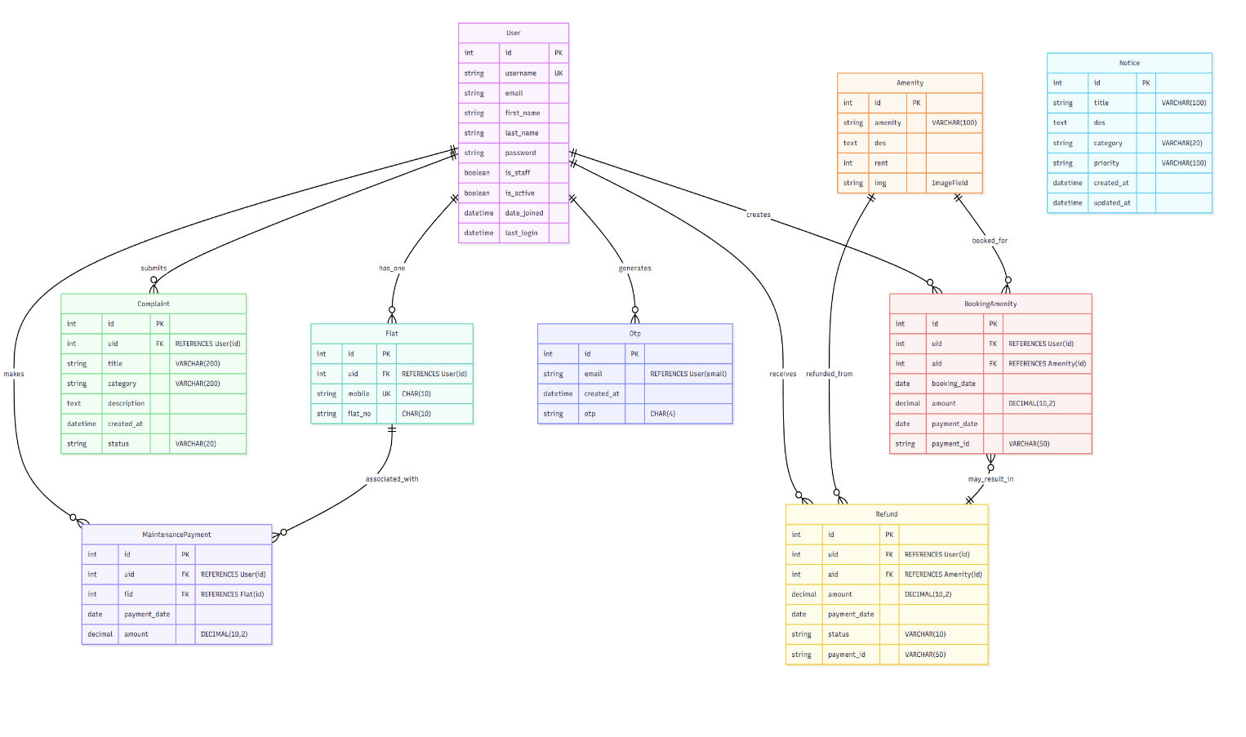

**3.3 Table Structure**

**auth_user Table (Django Default - Inferred Structure)**

CREATE TABLE auth_user (

id INT AUTO_INCREMENT PRIMARY KEY,

password VARCHAR(128) NOT NULL,

last_login DATETIME,

is_superuser BOOLEAN NOT NULL,

username VARCHAR(150) UNIQUE NOT NULL,

first_name VARCHAR(150) NOT NULL,

last_name VARCHAR(150) NOT NULL,

email VARCHAR(254) NOT NULL,

is_staff BOOLEAN NOT NULL,

is_active BOOLEAN NOT NULL,

date_joined DATETIME NOT NULL

);

**Flat Table**

CREATE TABLE society360_flat (

id INT AUTO_INCREMENT PRIMARY KEY,

uid INT NOT NULL,

mobile VARCHAR(10) UNIQUE,

flat_no VARCHAR(10),

FOREIGN KEY (uid) REFERENCES auth_user(id) ON DELETE CASCADE

);

**Notice Table**

CREATE TABLE society360_notice (

id INT AUTO_INCREMENT PRIMARY KEY,

title VARCHAR(100) NOT NULL,

description TEXT NOT NULL,

category VARCHAR(20) NOT NULL,

priority VARCHAR(100) NOT NULL,

created_at DATETIME,

updated_at DATETIME

);

**Amenity Table**

CREATE TABLE society360_amenity (

id INT AUTO_INCREMENT PRIMARY KEY,

amenity VARCHAR(100) NOT NULL,

description TEXT NOT NULL,

rent INT NOT NULL,

img VARCHAR(100)

);

**Maintenance_Payment Table**

CREATE TABLE society360_maintenancepayment (

id INT AUTO_INCREMENT PRIMARY KEY,

uid INT NOT NULL,

fid INT,

payment_date DATE NOT NULL,

amount DECIMAL(10,2) NOT NULL,

FOREIGN KEY (uid) REFERENCES auth_user(id) ON DELETE CASCADE,

FOREIGN KEY (fid) REFERENCES society360_flat(id) ON DELETE SET NULL

);

**Bookingamenity Table**

CREATE TABLE society360_bookingamenity (

id INT AUTO_INCREMENT PRIMARY KEY,

uid INT NOT NULL,

aid INT NOT NULL,

booking_date DATE NOT NULL,

amount DECIMAL(10,2) NOT NULL,

payment_date DATE NOT NULL,

payment_id VARCHAR(50) DEFAULT 'xyz',

FOREIGN KEY (uid) REFERENCES auth_user(id) ON DELETE CASCADE,

FOREIGN KEY (aid) REFERENCES society360_amenity(id) ON DELETE CASCADE );

**Refund Table**

CREATE TABLE society360_refund (

id INT AUTO_INCREMENT PRIMARY KEY,

uid INT NOT NULL,

aid INT NOT NULL,

amount DECIMAL(10,2) NOT NULL,

payment_date DATE NOT NULL,

status VARCHAR(10) DEFAULT 'Pending',

payment_id VARCHAR(50),

FOREIGN KEY (uid) REFERENCES auth_user(id) ON DELETE CASCADE,

FOREIGN KEY (aid) REFERENCES society360_amenity(id) ON DELETE CASCADE

);

**Complaint Table**

CREATE TABLE society360_complaint (

id INT AUTO_INCREMENT PRIMARY KEY,

uid INT NOT NULL,

title VARCHAR(200) NOT NULL,

category VARCHAR(200) NOT NULL,

description TEXT NOT NULL,

created_at DATETIME,

status VARCHAR(20) DEFAULT 'Pending',

FOREIGN KEY (uid) REFERENCES auth_user(id) ON DELETE CASCADE

);

**Otp Table**

CREATE TABLE society360_otp (

id INT AUTO_INCREMENT PRIMARY KEY,

email VARCHAR(254) NOT NULL,

created_at DATETIME,

otp VARCHAR(4) NOT NULL

);

**3.4 Use Case Diagrams**

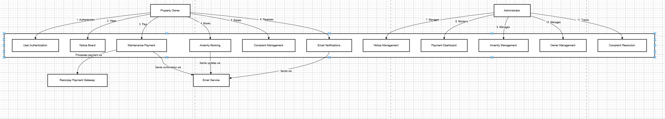

**3.5 Class Diagram**

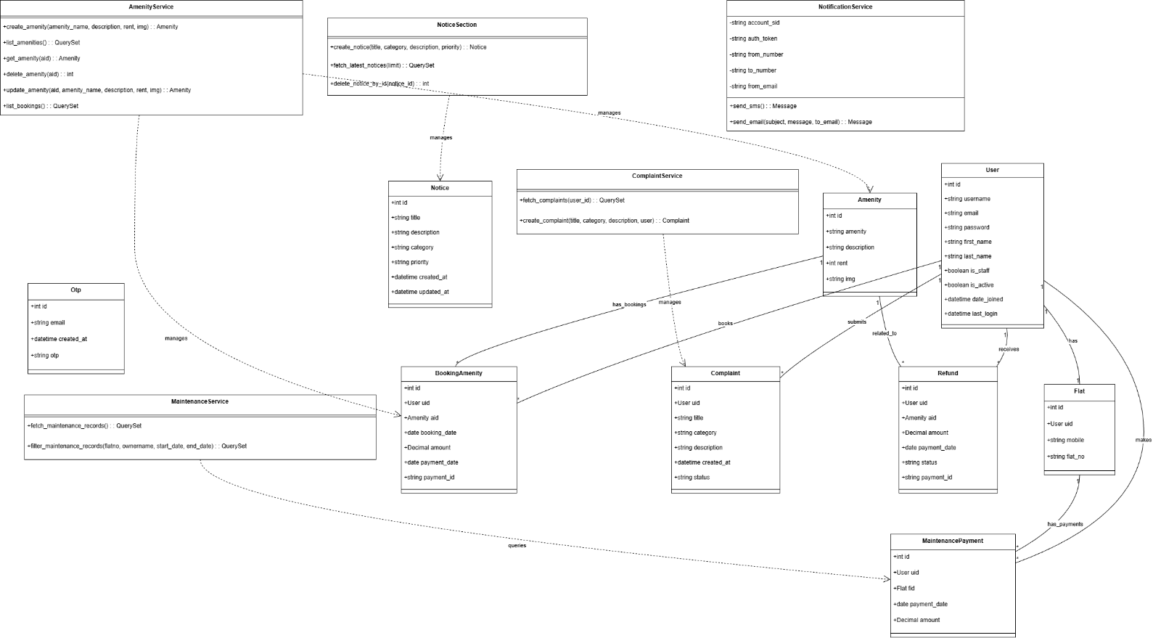

**3.6 Sequence Diagram**

**1. Notice Creation Flow**

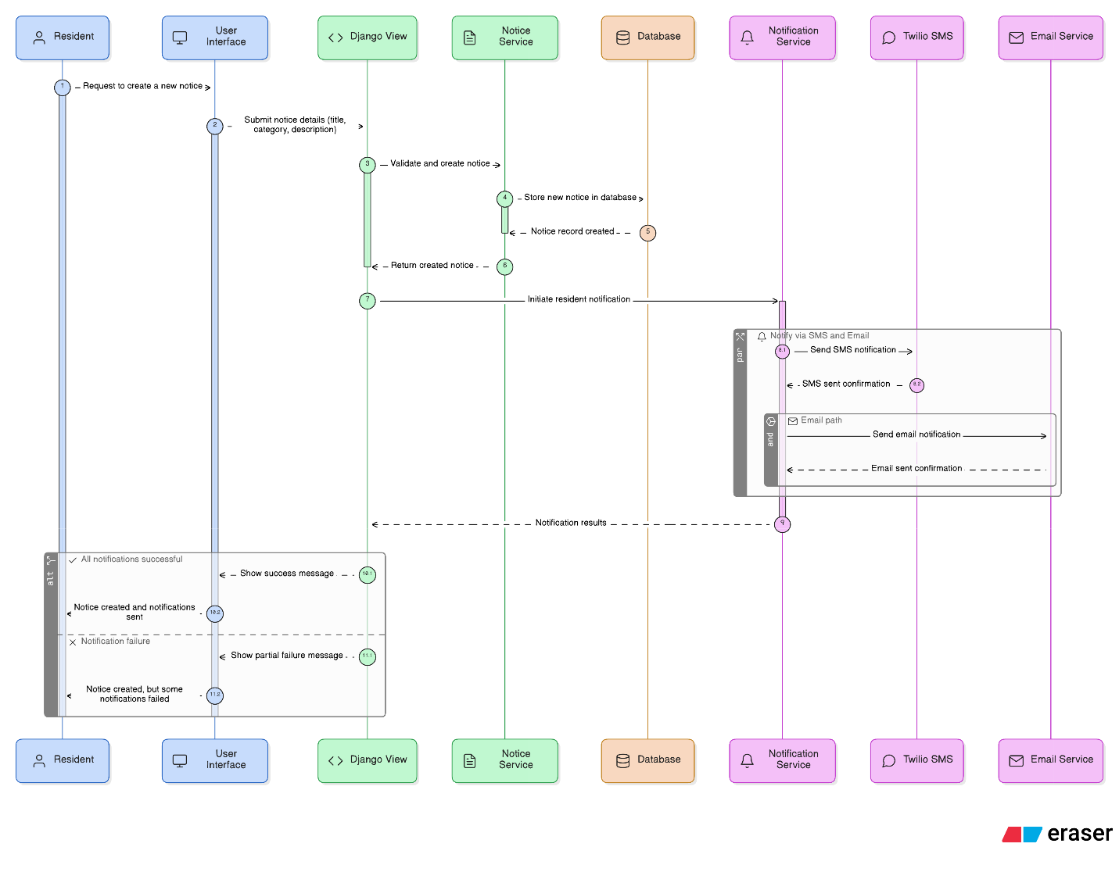

**2. Maintenance Payment Flow**

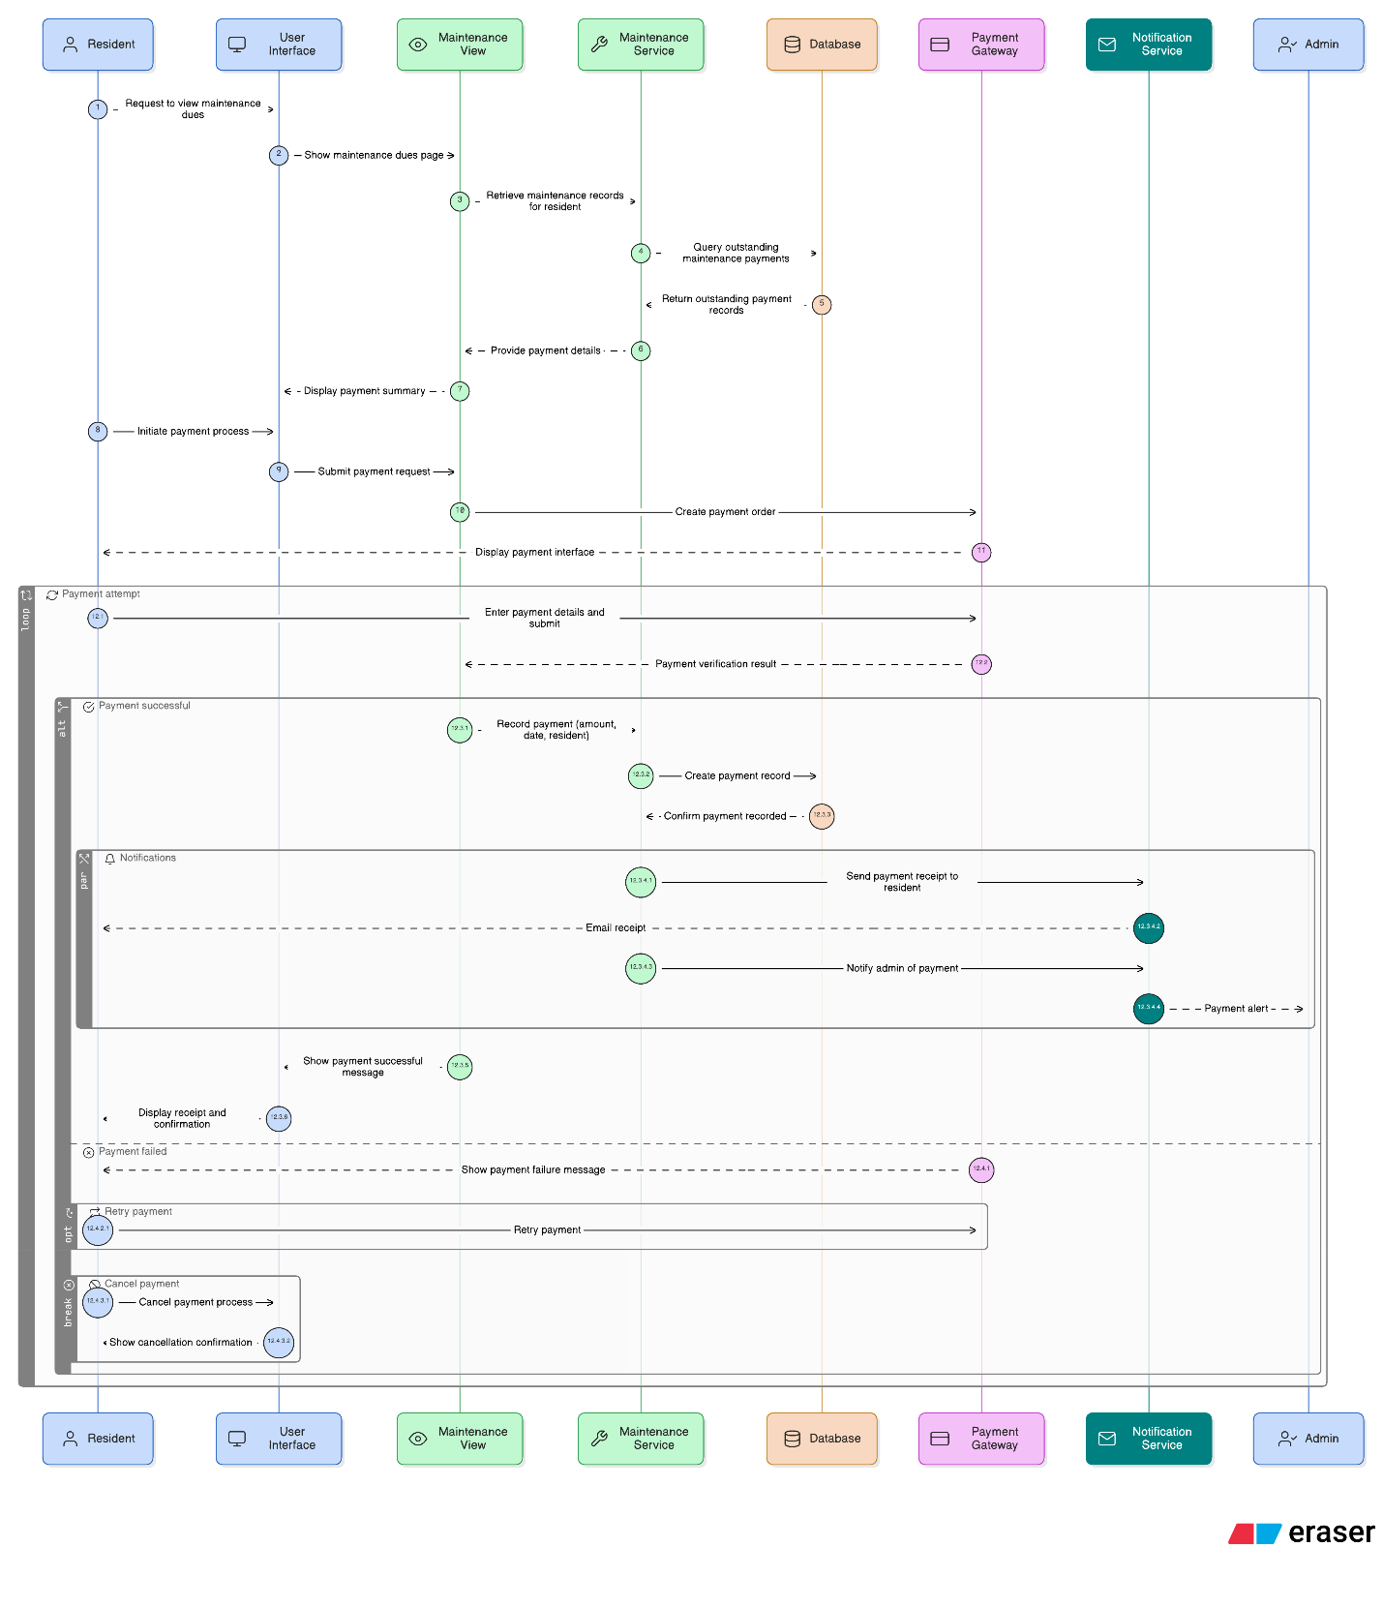

**3. Amenity Booking Flow**

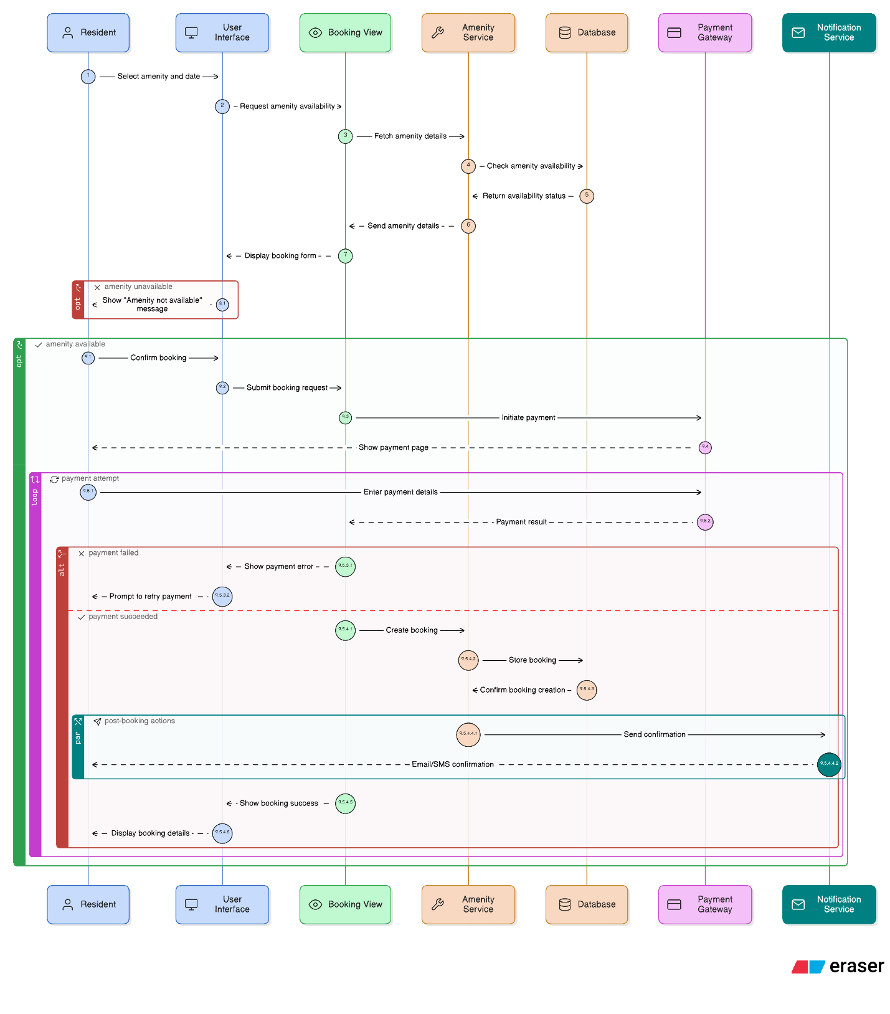

**4. Raise Complaint Flow**

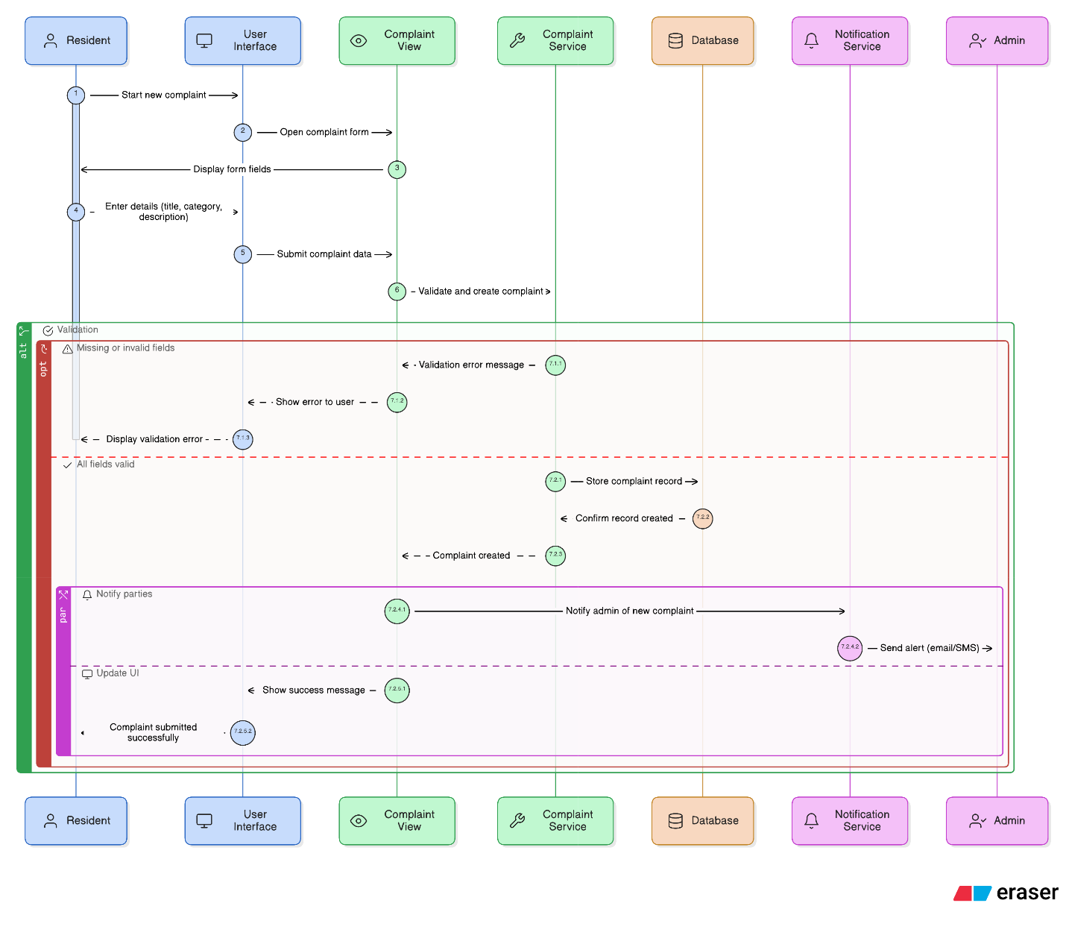

**3.7 Deployment Diagram**

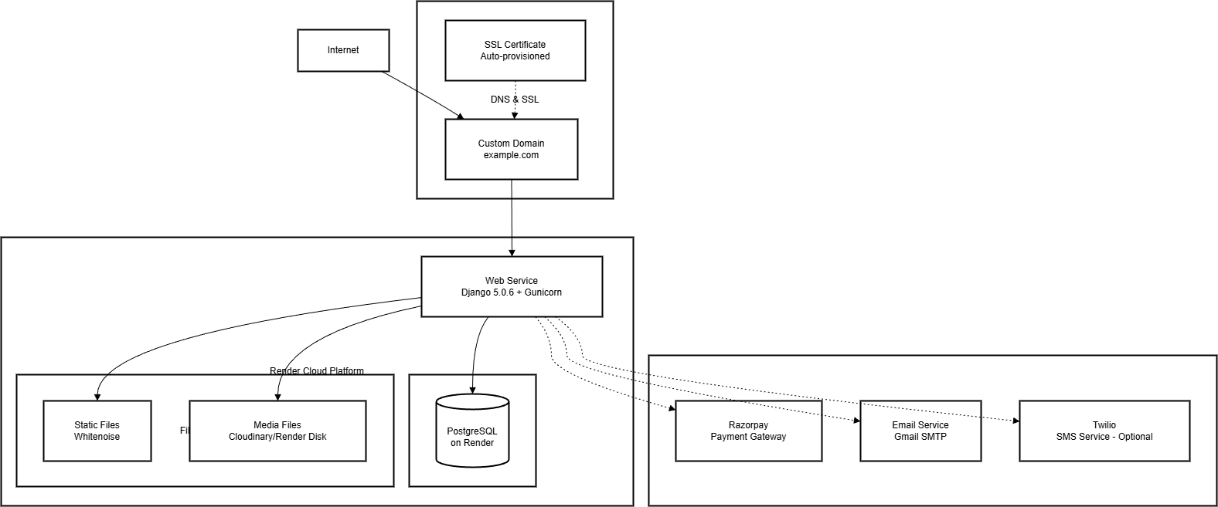

**3.8 Input and Output Screens**

**A. Owner/Tenant Screens**

**3.8.1. Home Page**

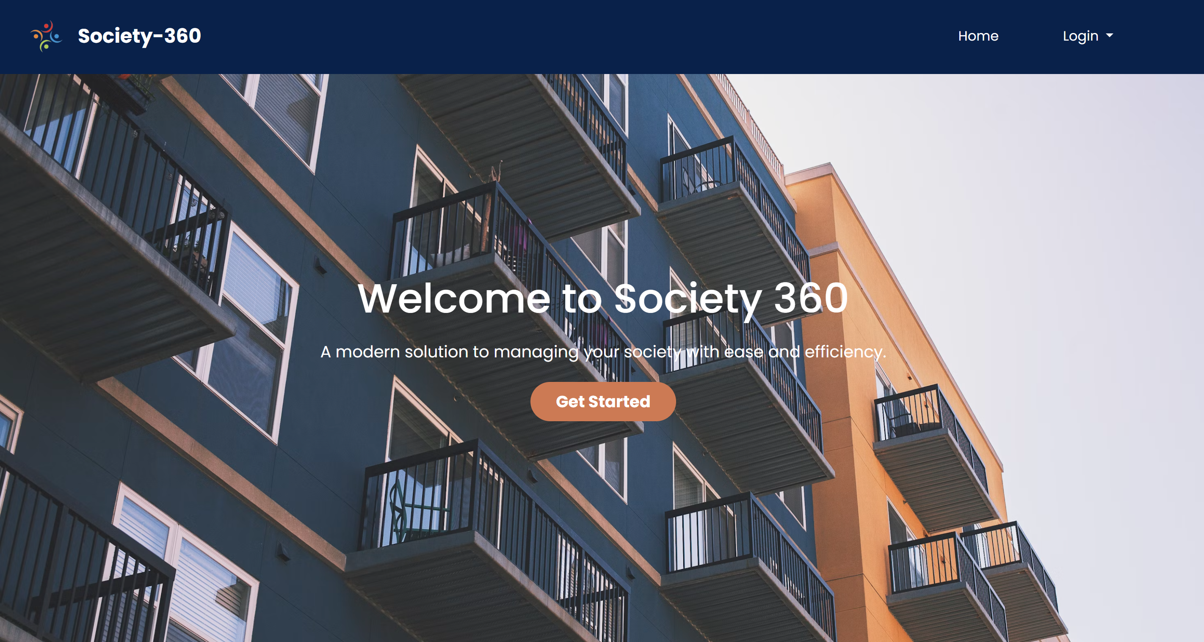

**3.8.2. Notice Section**

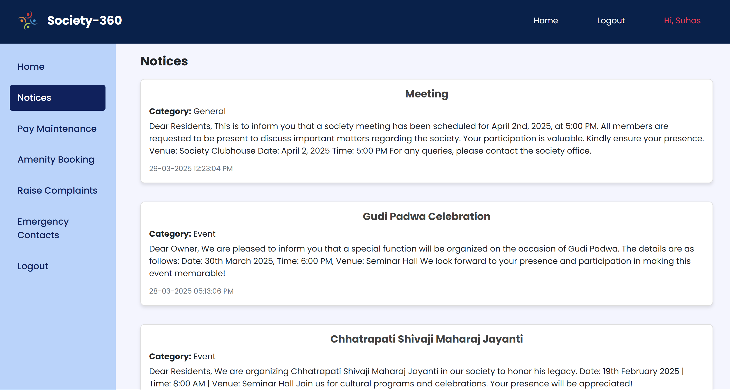

**3.8.3. Maintenance Payment Section**

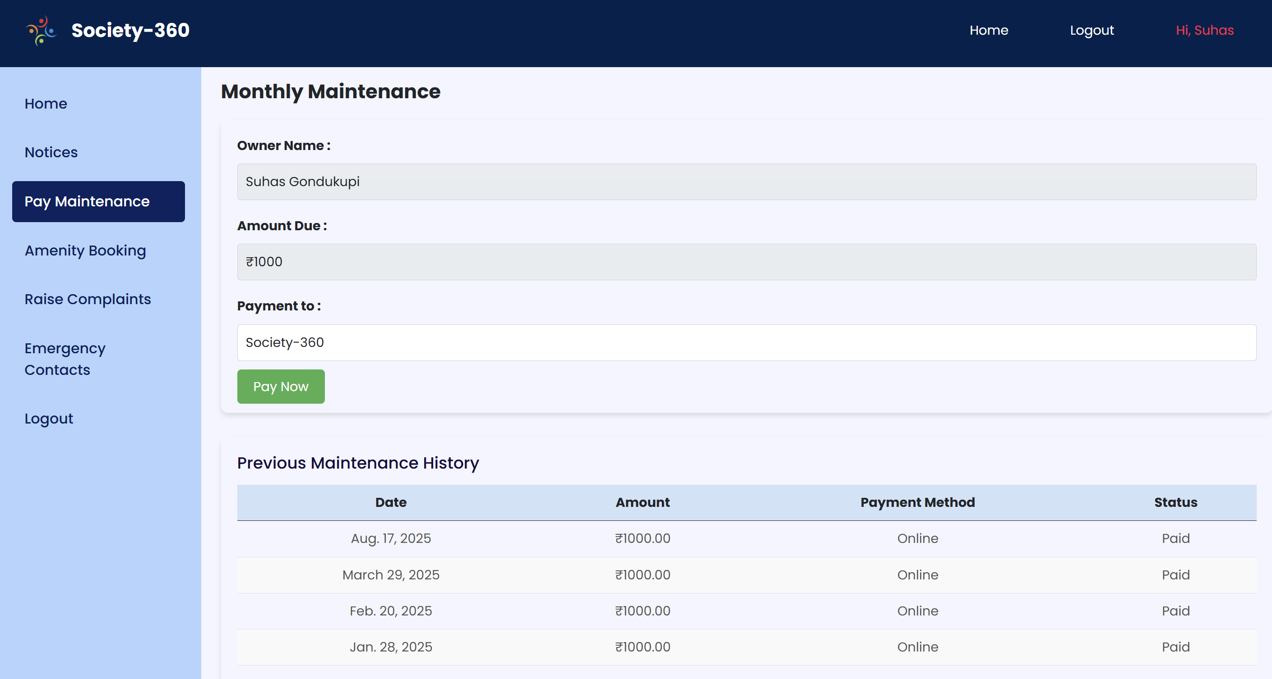

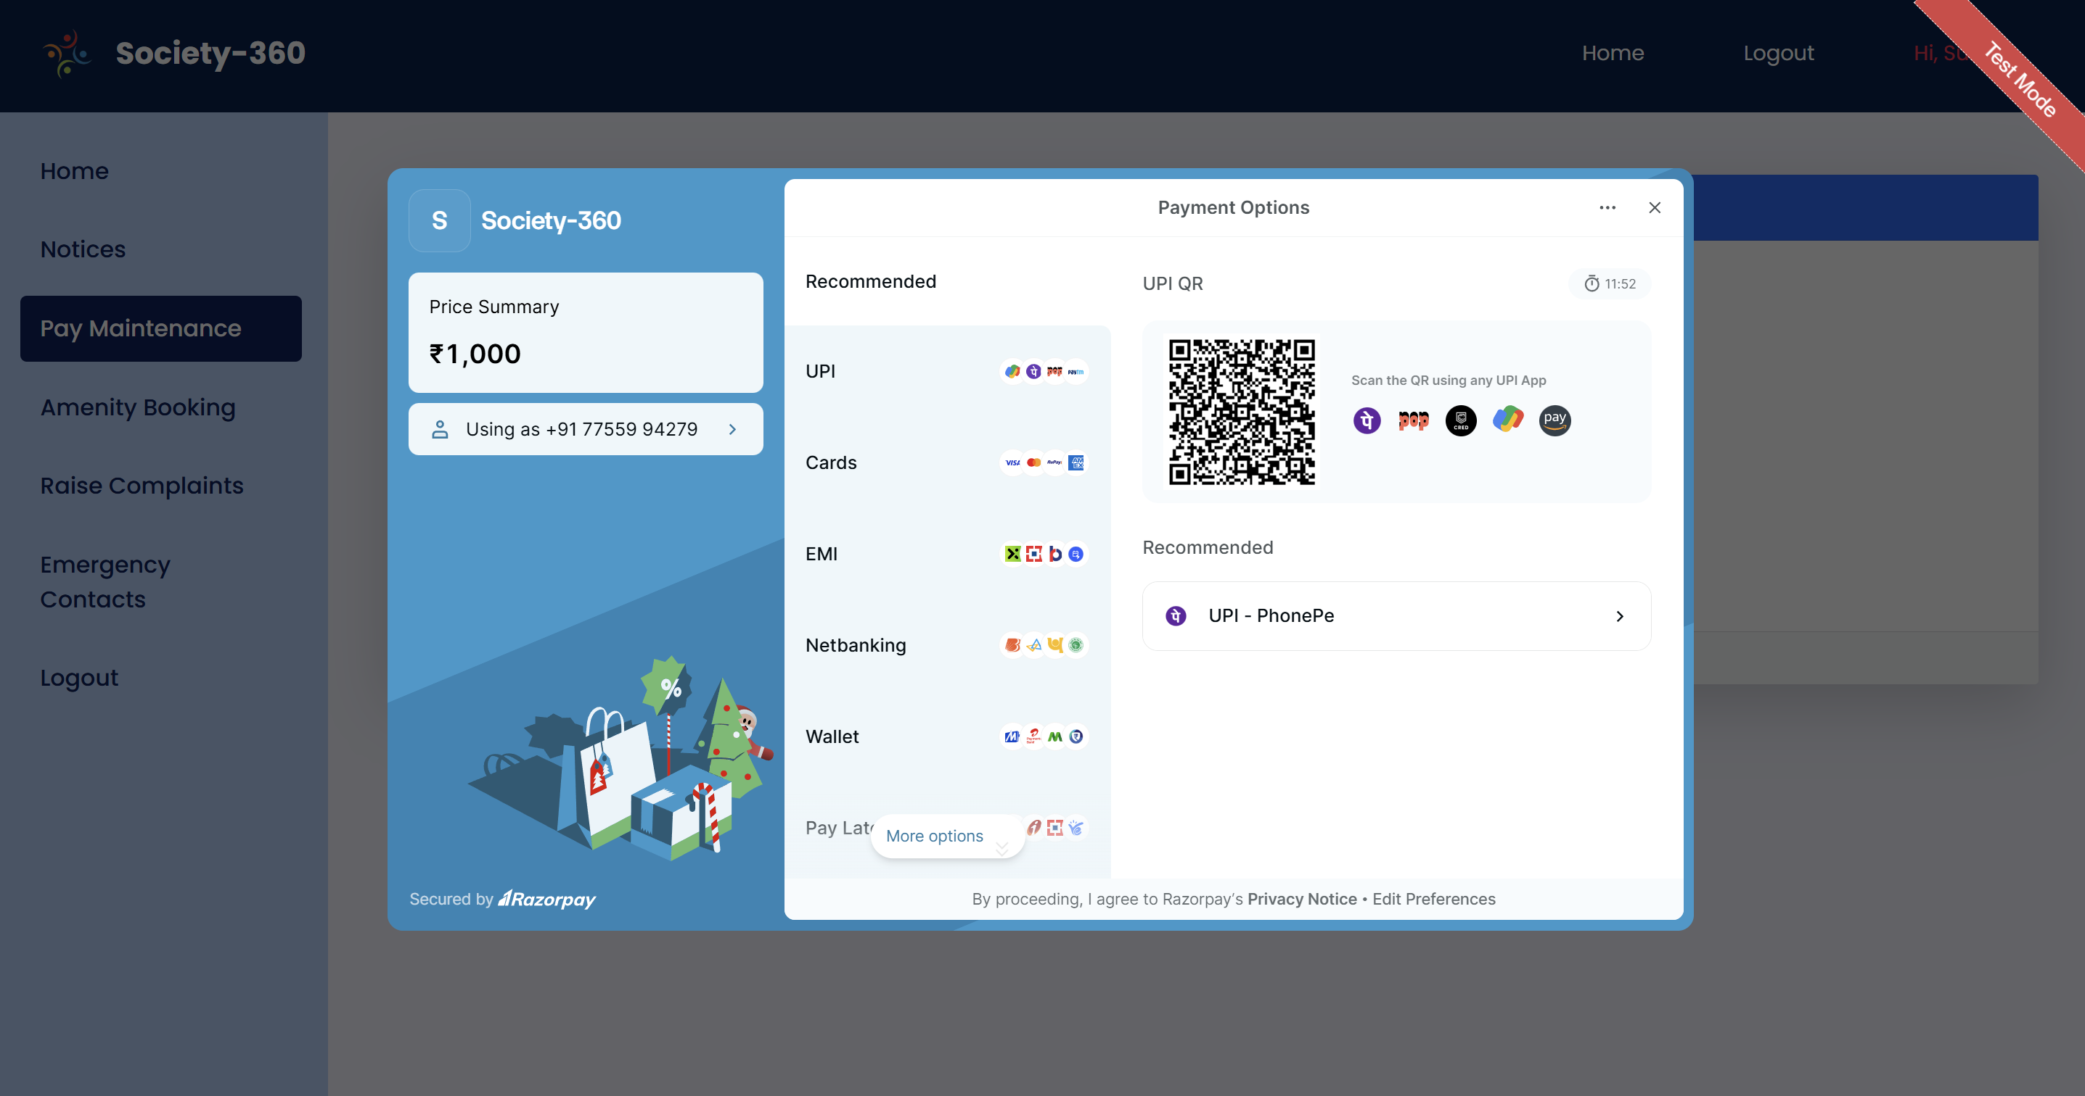

**3.8.4. Complaint Section**

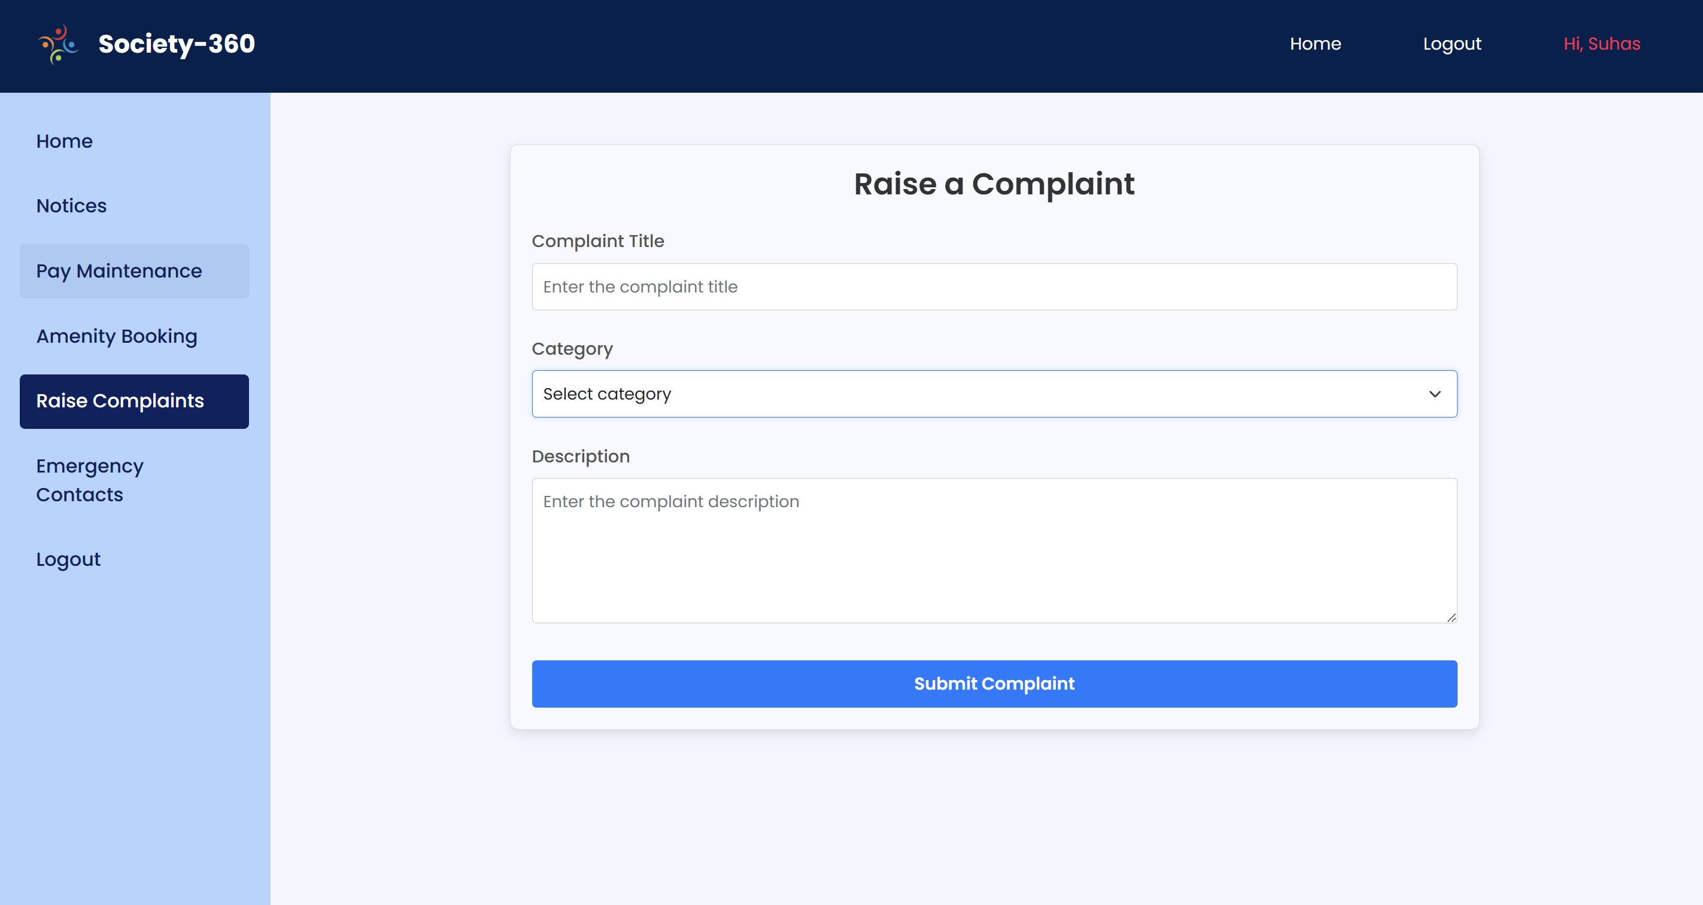

**3.8.5. Amenity Booking Section**

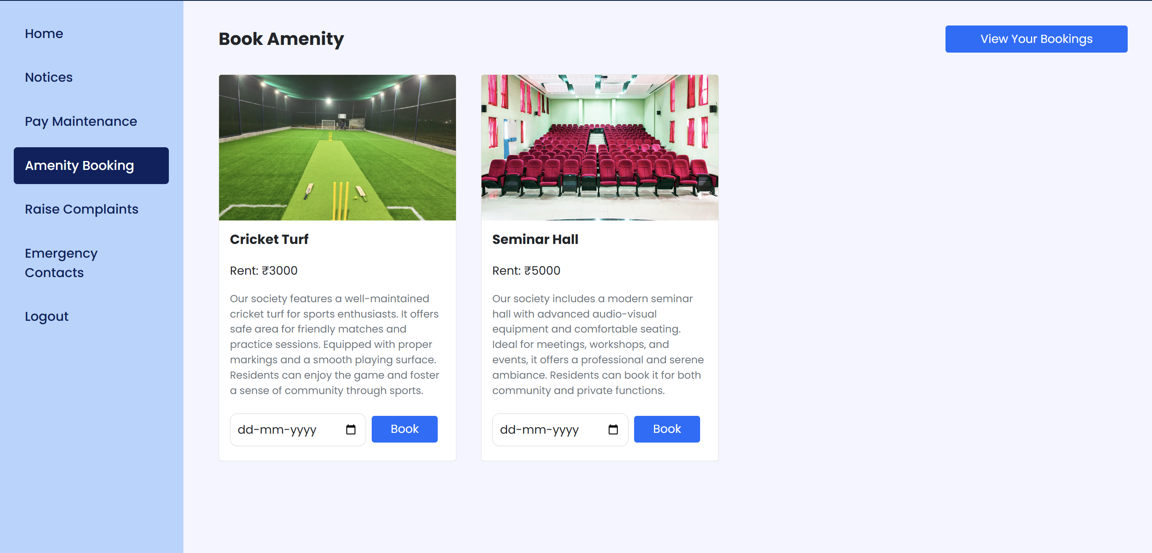

**B. Admin Screens**

**3.8.6. Admin Dashboard Page**

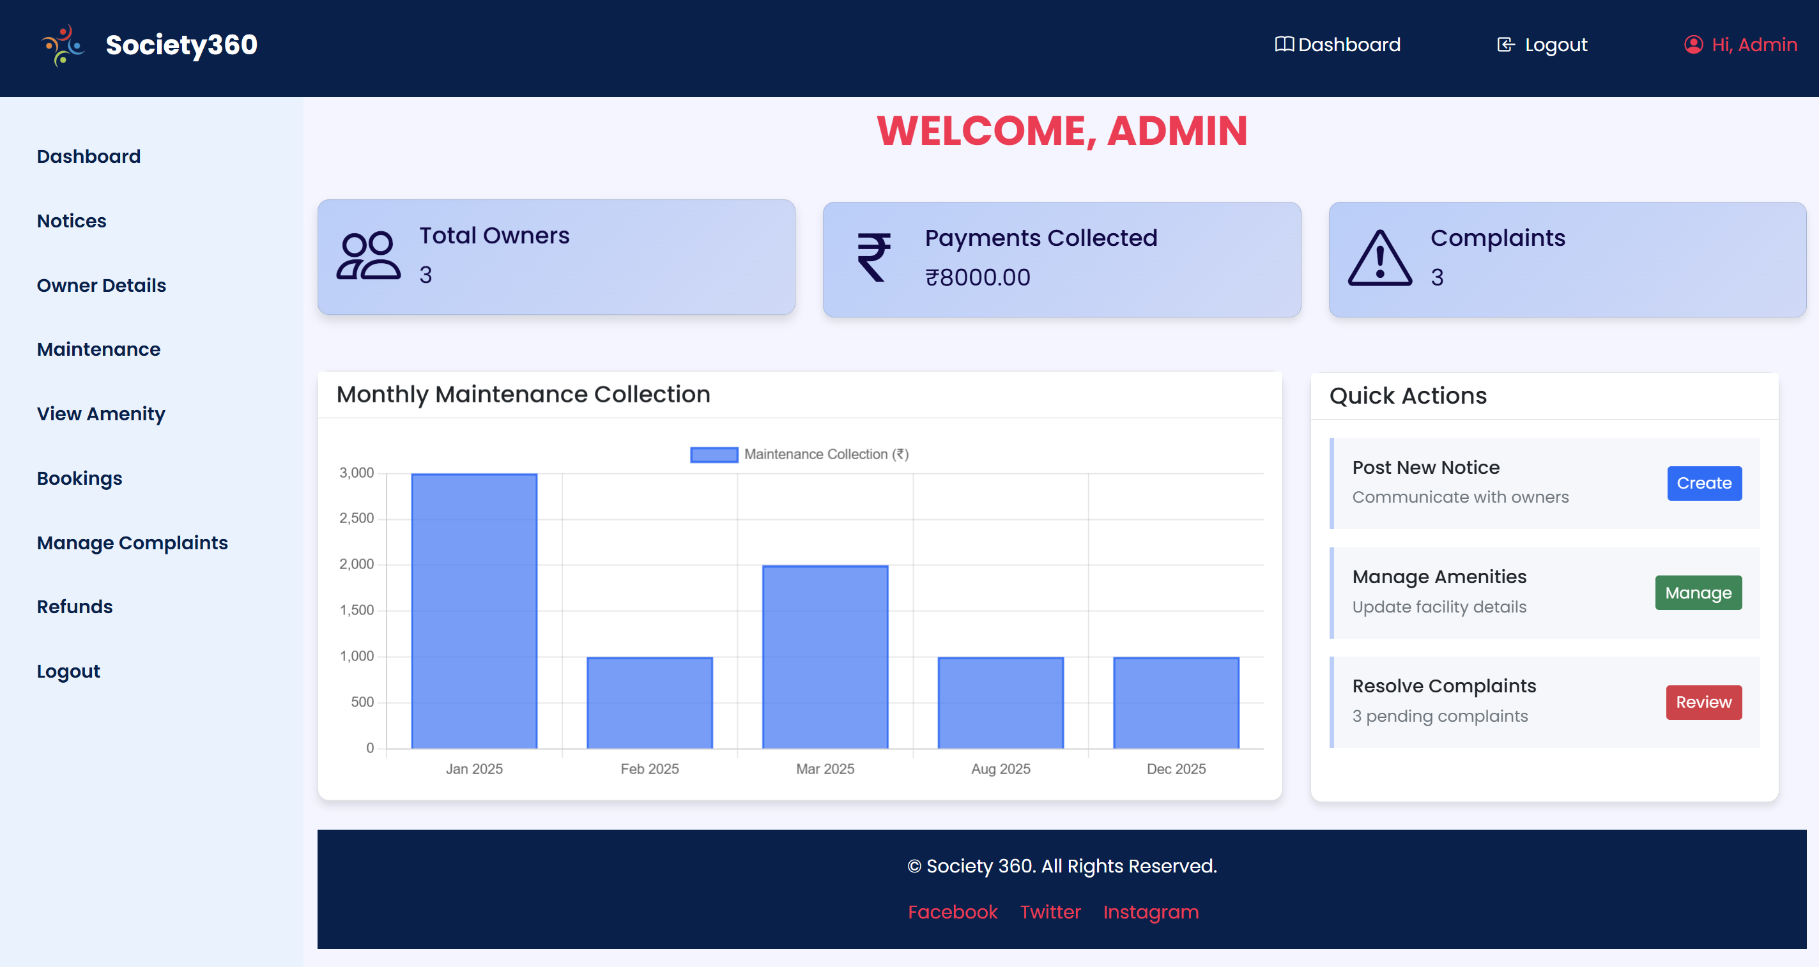

**3.8.7. Notice Creation Page**

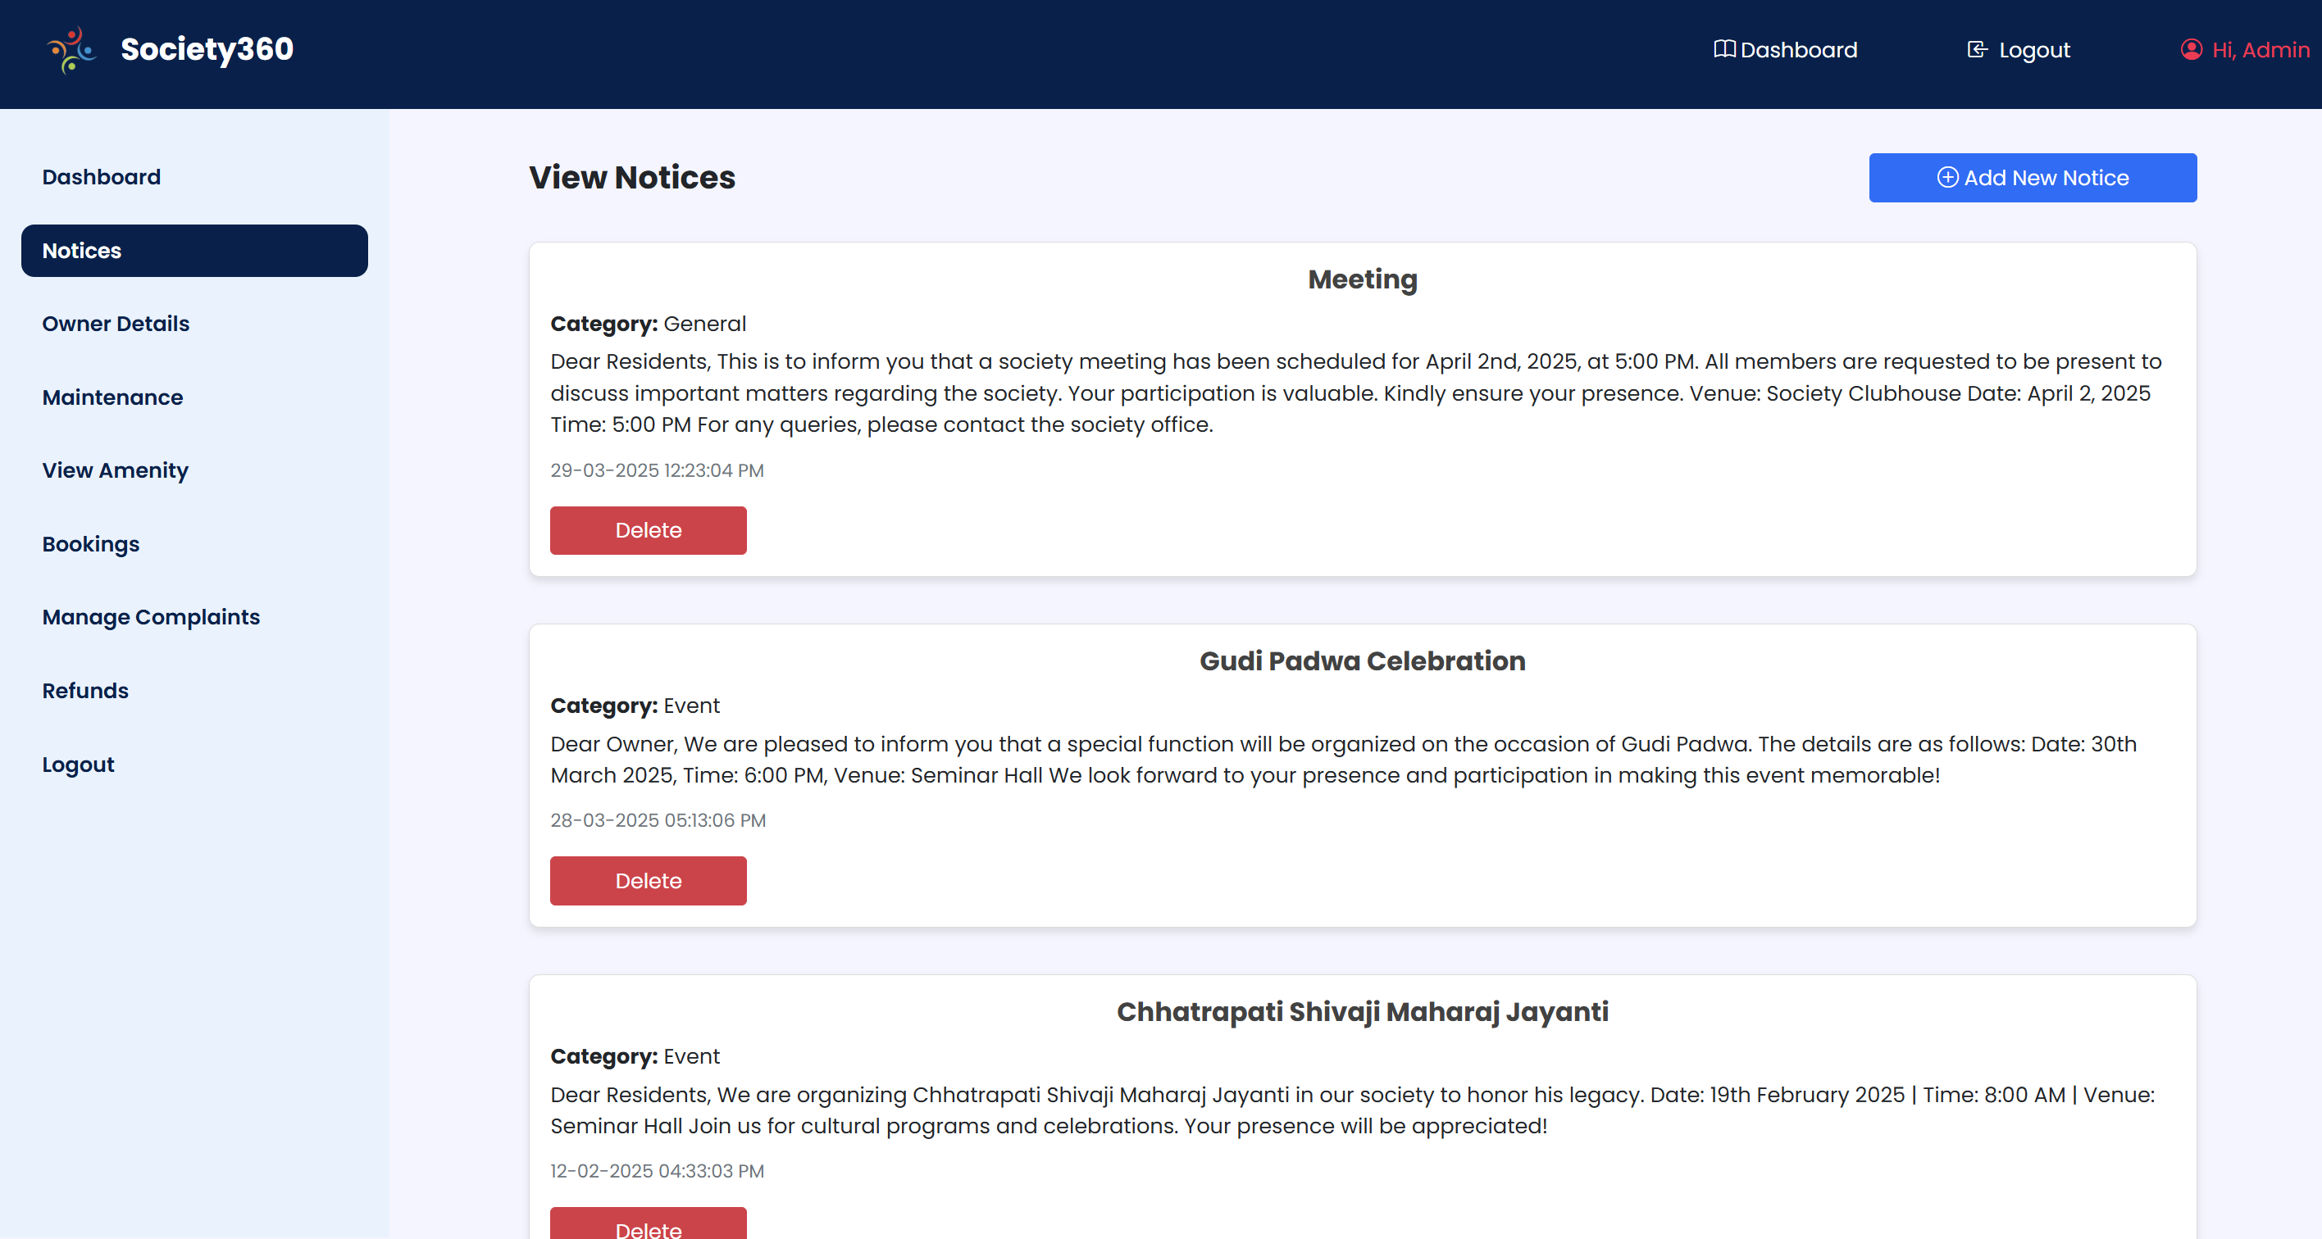

**3.8.8. Maintenance History Page**

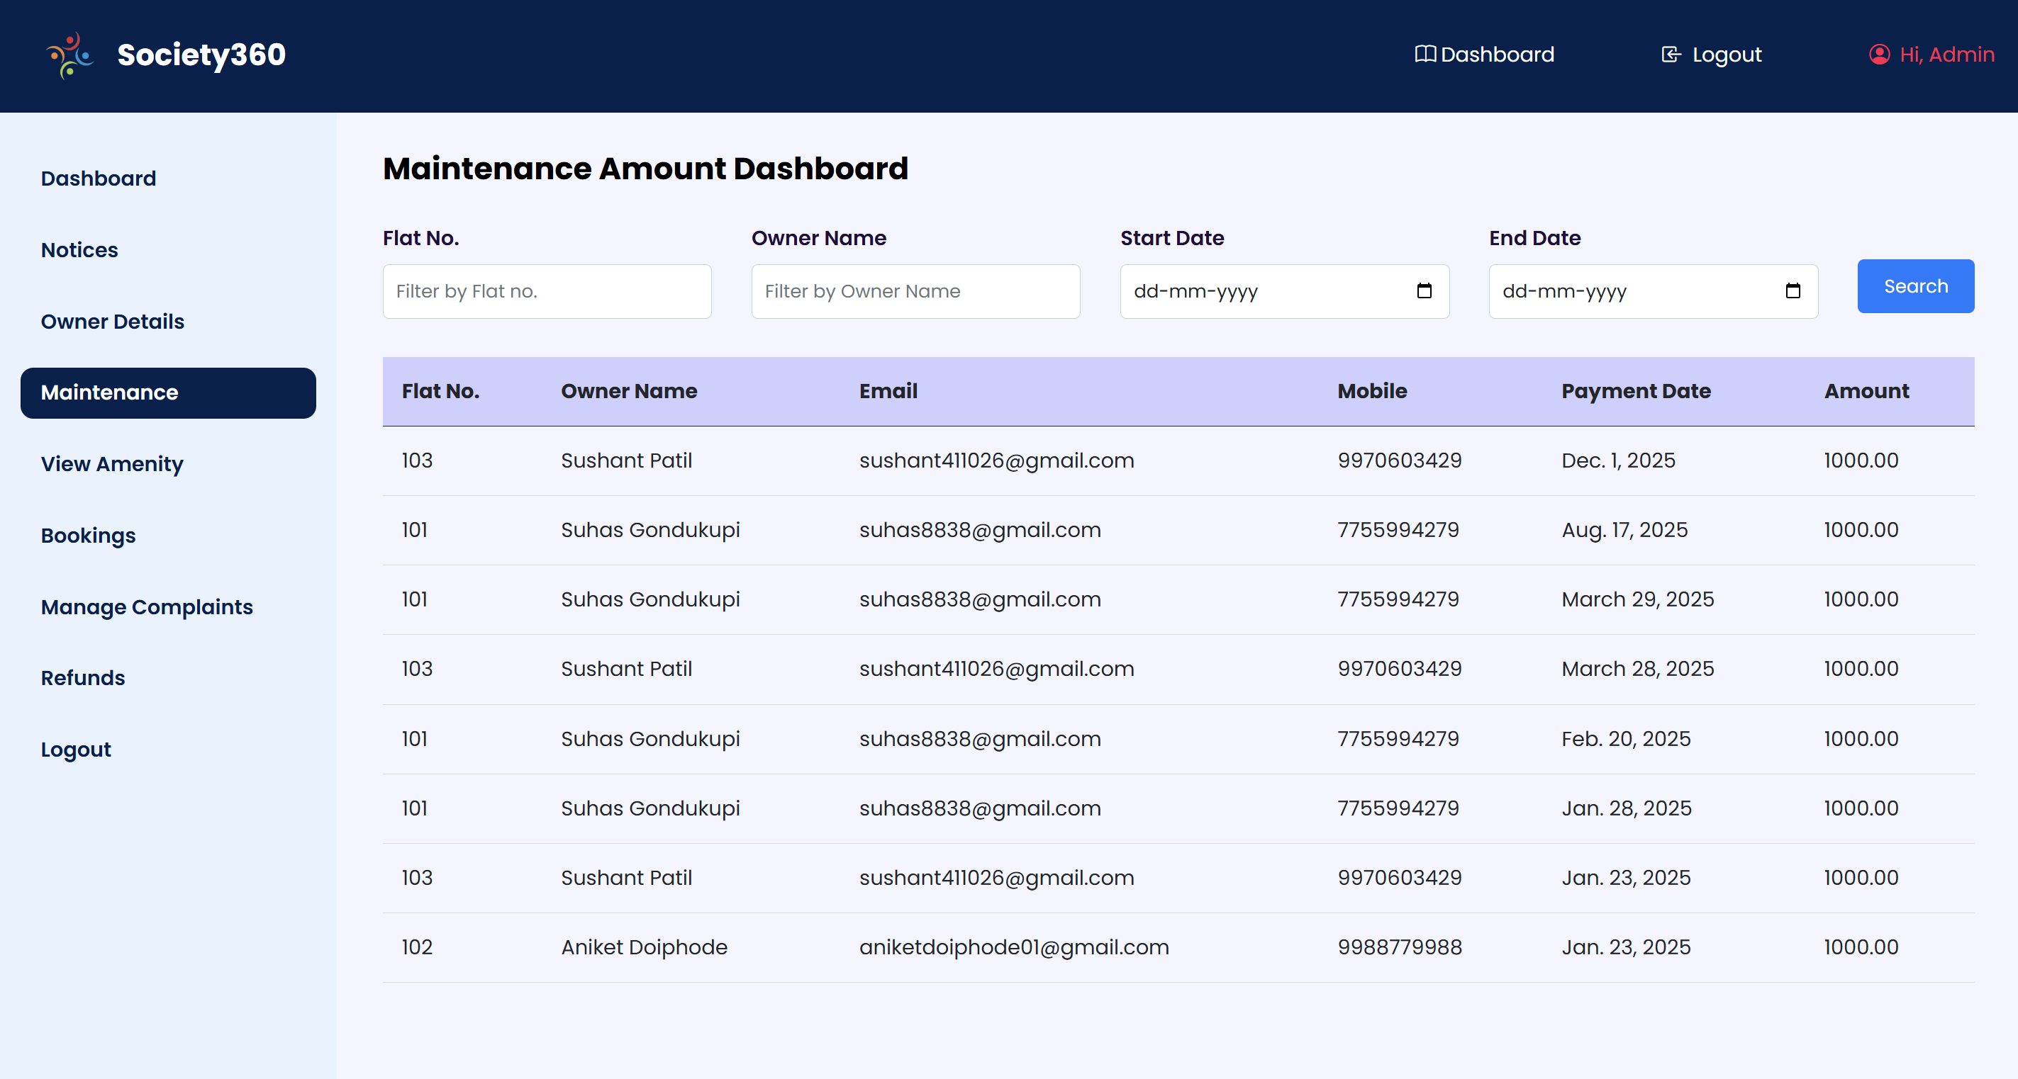

**3.8.9. Complaint Resolution Section**

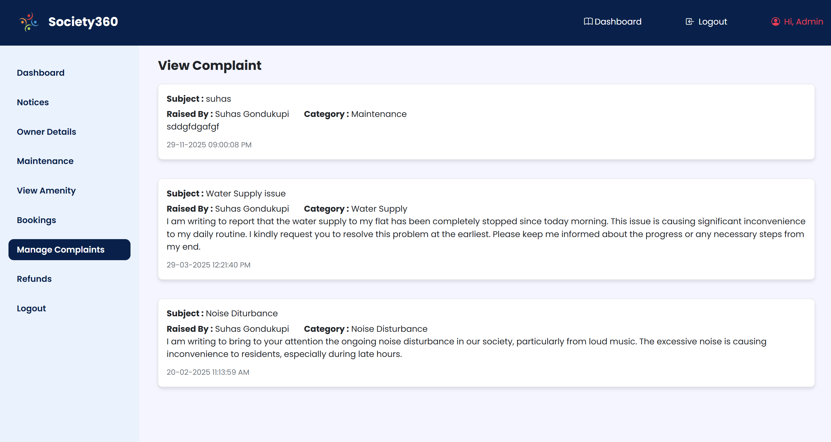

**3.8.10. View Booked Amenities**

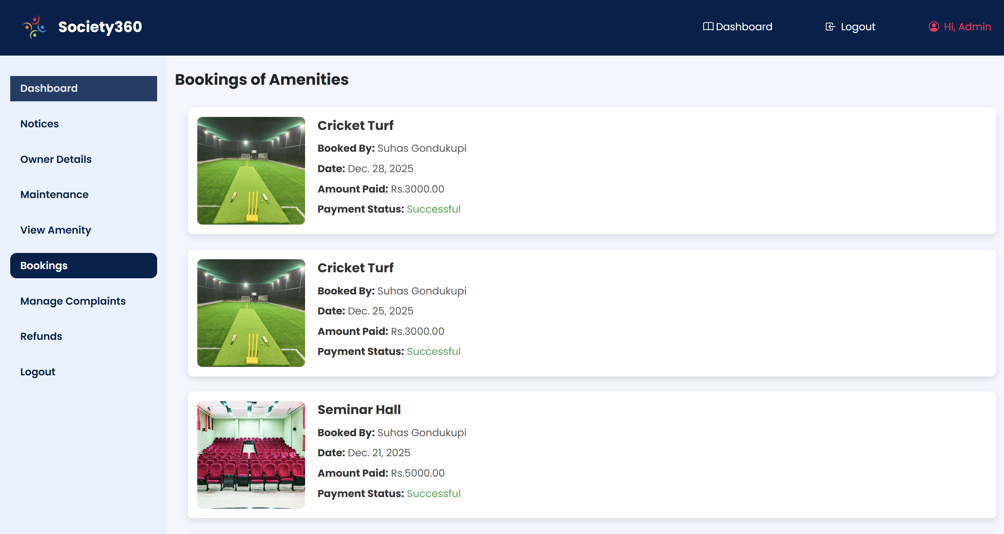

**Chapter 4: Coding**

**4.1 Algorithms**

**4.1.1 User Registration Algorithm**

Algorithm: Owner_Registration

Input: username, email, password, confirm_password, mobile, flat_number

Output: Registration success status and message

BEGIN

// Step 1: Input Validation

IF username == "" OR email == "" OR password == "" OR confirm_password == "" OR mobile == "" OR flat_number == "" THEN

RETURN "error", "All fields are required"

END IF

// Step 2: Password Validation

IF password.length < 8 THEN

RETURN "error", "Password must be at least 8 characters long"

END IF

IF password ≠ confirm_password THEN

RETURN "error", "Passwords do not match"

END IF

// Step 3: Check Flat Availability

IF Flat.objects.filter(flat_no == flat_number).exists() THEN

RETURN "error", "Flat already registered"

END IF

// Step 4: Check Email Uniqueness

IF User.objects.filter(email == email).exists() THEN

RETURN "error", "Email already registered"

END IF

// Step 5: Create User Record (Atomic Transaction)

BEGIN TRANSACTION

TRY

// Create Django User

user = CREATE_NEW_USER(

username: email,

email: email,

first_name: username,

password: hash_password(password)

)

// Create Flat Record

flat = CREATE_FLAT_RECORD(

uid: user.id,

mobile: mobile,

flat_no: flat_number

)

COMMIT TRANSACTION

RETURN "success", "Registration successful"

CATCH IntegrityError

ROLLBACK TRANSACTION

RETURN "error", "Database integrity error occurred"

CATCH ValidationError

ROLLBACK TRANSACTION

RETURN "error", "Invalid data provided"

CATCH Exception

ROLLBACK TRANSACTION

RETURN "error", "Unexpected error occurred"

END TRY

END TRANSACTION

END

**4.1.2 Owner Login Authentication Algorithm**

Algorithm: Owner_Login

Input: email, password

Output: Authentication status and redirect URL

BEGIN

// Step 1: Input Validation

IF email == "" OR password == "" THEN

RETURN "error", "Please fill in both fields", "/owner-login"

END IF

// Step 2: User Authentication

authenticated_user = AUTHENTICATE_USER(

username: email,

password: password

)

// Step 3: Check Authentication Result

IF authenticated_user == NULL THEN

RETURN "error", "Invalid credentials", "/owner-login"

END IF

// Step 4: Login User (Create Session)

LOGIN_USER(authenticated_user)

// Step 5: Redirect to Dashboard

RETURN "success", "Login successful", "/owner-home"

END

**4.1.3 Maintenance Payment Processing Algorithm**

Algorithm: Process_Maintenance_Payment

Input: user_id, amount

Output: Payment status and transaction details

BEGIN

// Step 1: Check Current Month Payment Status

current_date = GET_CURRENT_DATE()

current_month = current_date.month

current_year = current_date.year

// Step 2: Prevent Duplicate Payment

IF MaintenancePayment.objects.filter(

uid == user_id AND

payment_date.month == current_month AND

payment_date.year == current_year

).exists() THEN

RETURN "error", "Payment already made for this month"

END IF

// Step 3: Get Flat Details

flat_record = Flat.objects.get(uid == user_id)

IF flat_record == NULL THEN

RETURN "error", "Flat details not found"

END IF

// Step 4: Initialize Payment Gateway

razorpay_client = INITIALIZE_RAZORPAY(

api_key: RAZORPAY_API_KEY,

api_secret: RAZORPAY_API_SECRET

)

// Step 5: Create Payment Order

payment_order = CREATE_RAZORPAY_ORDER(

amount: amount * 100, // Convert to paise

currency: "INR",

receipt: "maintenance_" + current_date.toString()

)

IF payment_order == NULL THEN

RETURN "error", "Payment gateway error"

END IF

// Step 6: Store Pending Payment Record

payment_record = CREATE_MAINTENANCE_RECORD(

uid: user_id, fid: flat_record.id, payment_date: current_date, amount: amount,

razorpay_order_id: payment_order.id

)

RETURN "success", payment_order, payment_record.id

END

**4.1.4 Amenity Booking Algorithm**

Algorithm: Book_Amenity

Input: user_id, amenity_id, booking_date

Output: Booking status and payment details

BEGIN

// Step 1: Validate Booking Date

current_date = GET_CURRENT_DATE()

IF booking_date < current_date THEN

RETURN "error", "Cannot book past dates"

END IF

// Step 2: Check Amenity Existence

amenity = Amenity.objects.get(id == amenity_id)

IF amenity == NULL THEN

RETURN "error", "Amenity not found"

END IF

// Step 3: Check Availability (No Double Booking)

IF BookingAmenity.objects.filter(

aid == amenity_id AND booking_date == booking_date AND payment_id≠"cancelled"

).exists() THEN

RETURN "error", "Amenity already booked for selected date"

END IF

// Step 4: Get Amenity Cost

amount = amenity.rent

// Step 5: Initialize Payment

razorpay_client = INITIALIZE_RAZORPAY(

api_key: RAZORPAY_API_KEY,

api_secret: RAZORPAY_API_SECRET

)

// Step 6: Create Payment Order

payment_order = CREATE_RAZORPAY_ORDER(

amount: amount * 100,

currency: "INR",

receipt: "amenity_" + amenity_id + "_" + booking_date.toString()

)

// Step 7: Create Booking Record

booking = CREATE_BOOKING_RECORD(

uid: user_id, aid: amenity_id, booking_date: booking_date, amount: amount,

payment_date: current_date, payment_id: payment_order.id, status: "pending"

)

RETURN "success", payment_order, booking.id

END

**4.1.5 Complaint Submission Algorithm**

Algorithm: Submit_Complaint

Input: user_id, title, category, description

Output: Complaint ticket creation status

BEGIN

// Step 1: Input Validation

IF title == "" THEN

RETURN "error", "Title is required"

END IF

IF category == "" THEN

RETURN "error", "Category is required"

END IF

IF description == "" THEN

RETURN "error", "Description is required"

END IF

// Step 2: Create Complaint Ticket

complaint = CREATE_COMPLAINT_RECORD(

uid: user_id,

title: title,

category: category,

description: description,

status: "Pending",

created_at: GET_CURRENT_TIMESTAMP()

)

// Step 3: Generate Ticket Number

ticket_number = "TKT" + complaint.id.toString().padStart(6, '0')

RETURN "success", "Complaint raised successfully", ticket_number

END

**4.2 Code Snippets**

**4.2.1 User Authentication Snippet**

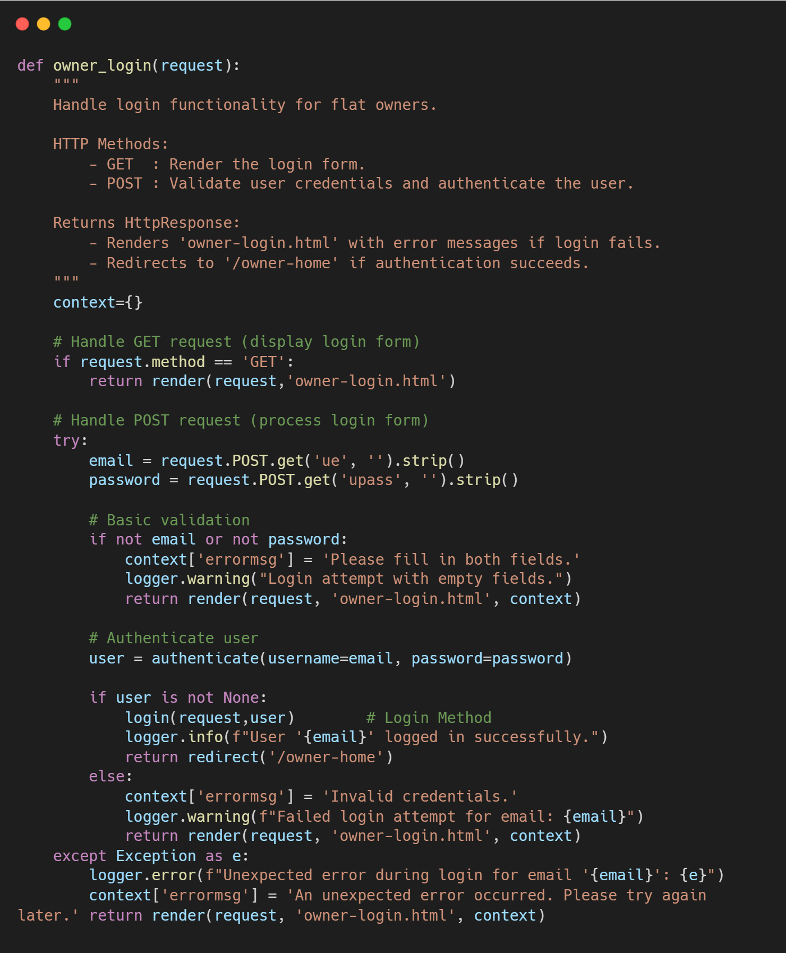

**4.2.2 Razorpay Payment Integration Snippet**

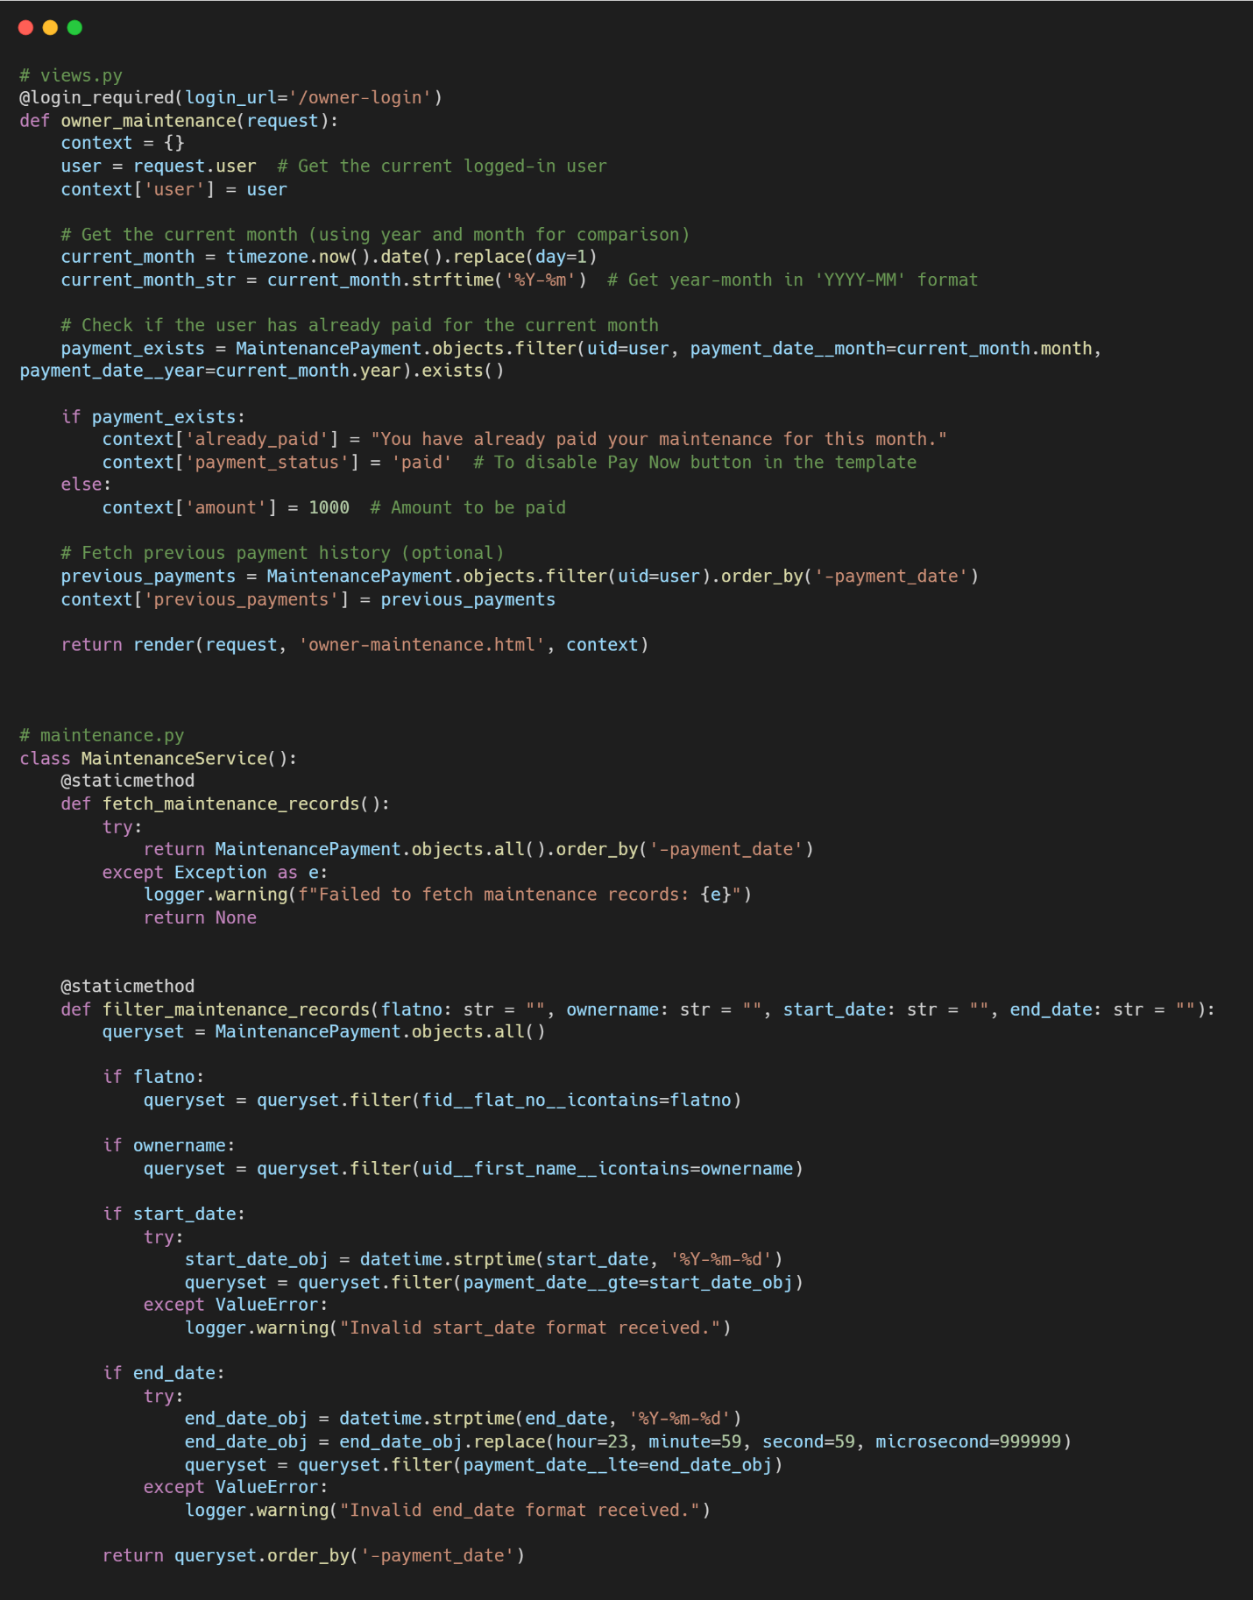

**4.2.3 Email Notification Service Snippet**

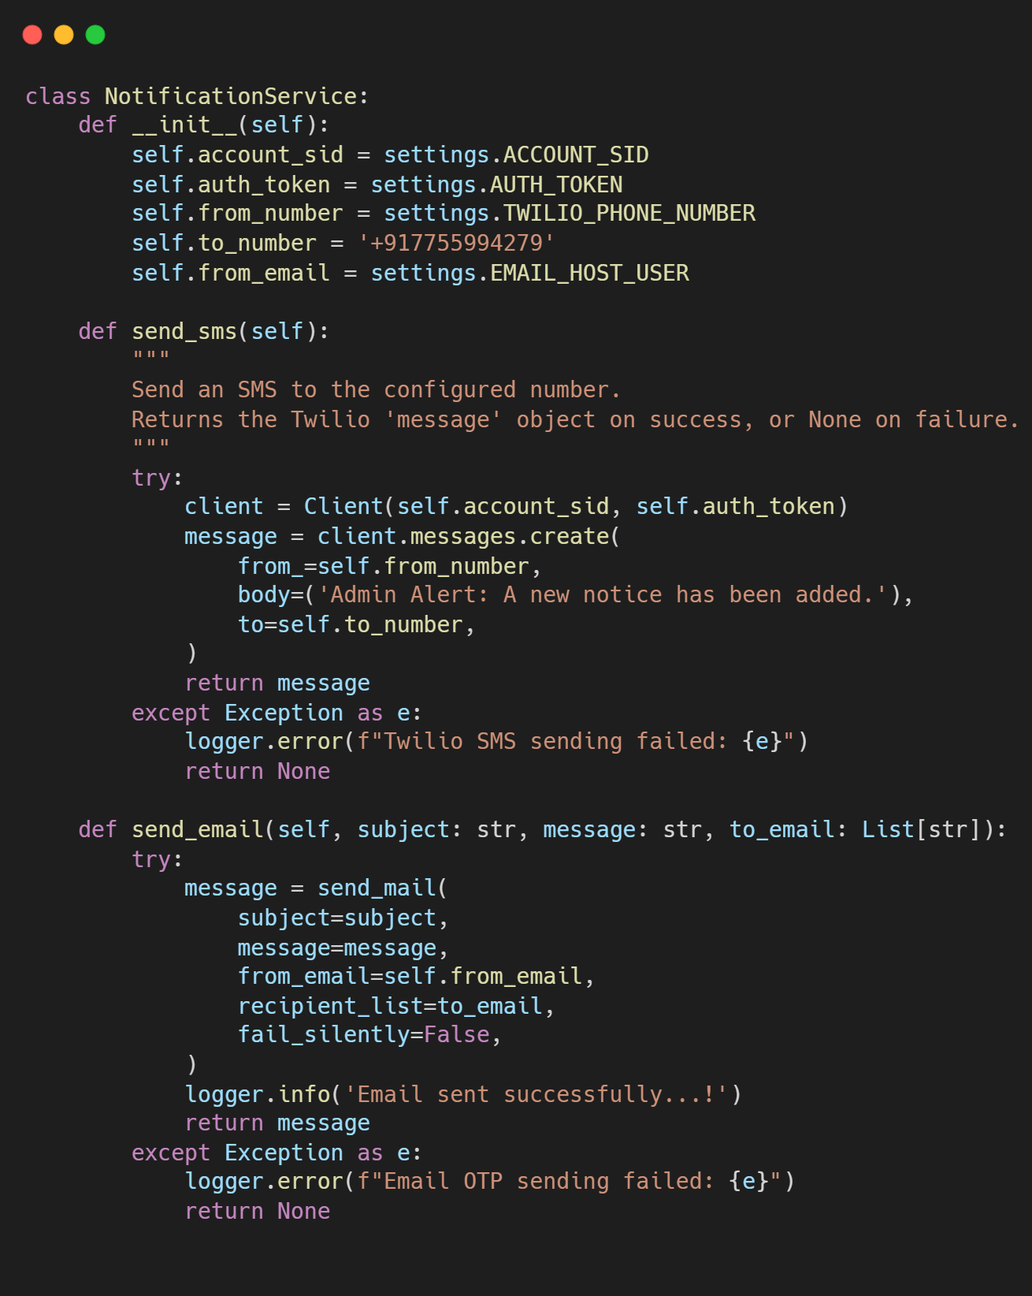

**4.2.4 Service Layer - Notice Management Snippet**

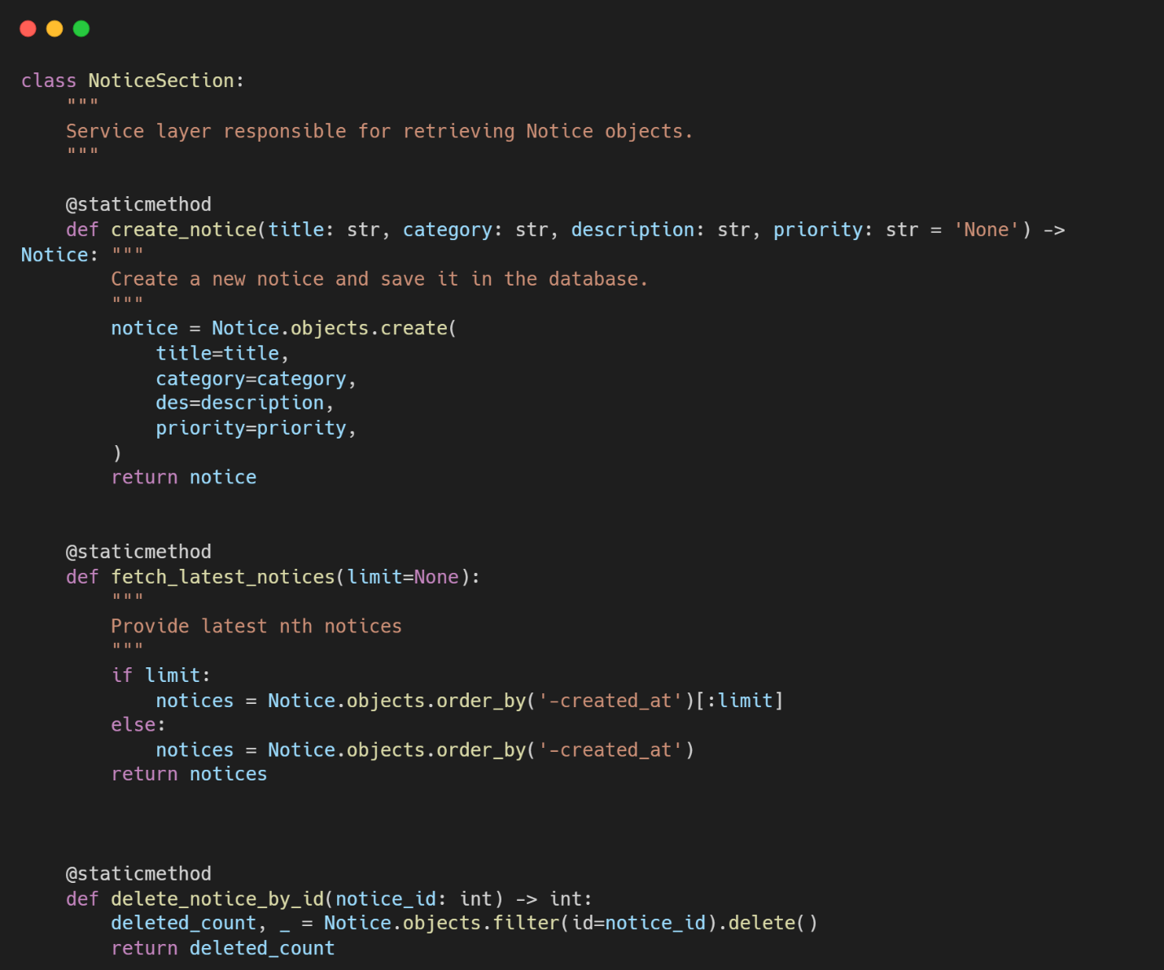

**4.2.4 Service Layer - Complaint Management Snippet, Amenity Management Snippet**

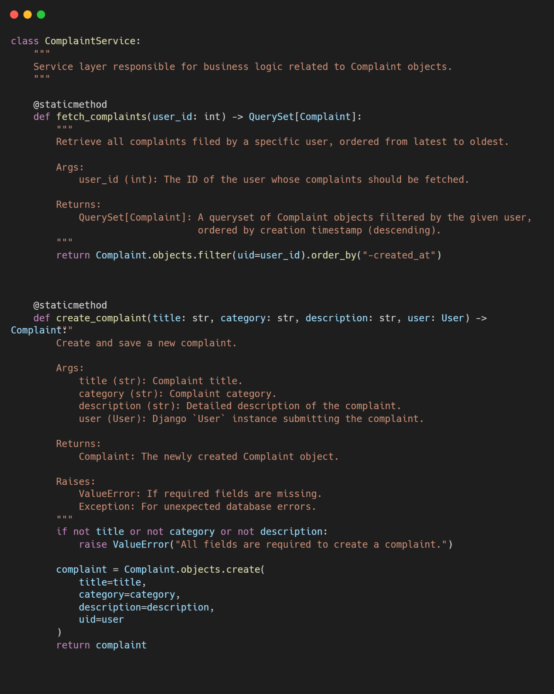

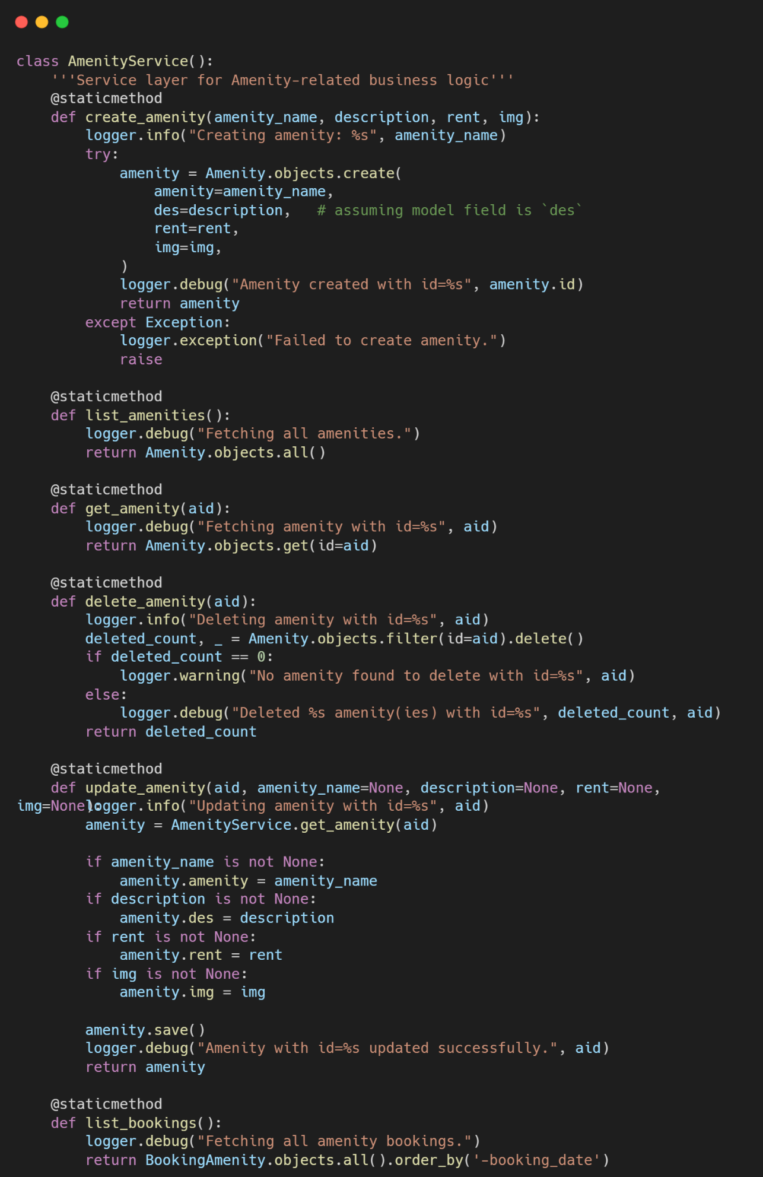

**Chapter 5: Testing**

**5.1 Test Strategy**

* **Testing Approach**: Manual testing with exploratory testing approach
* **Test Levels**: Unit, Integration, System, and User Acceptance Testing
* **Test Environment**: Development server with test database
* **Test Data**: Realistic data mimicking actual society scenarios
* **Entry Criteria**: All modules developed and integrated
* **Exit Criteria**: 90% test cases passed, critical bugs resolved

**5.2 Unit Test Plan**

* **Testing Tools**: Django Test Framework, Python unittest
* **Scope**: Individual functions, models, and service classes
* **Key Areas**:
  + User authentication and registration logic
  + Notice creation and retrieval
  + Payment calculation and processing
  + Amenity booking validation
* **Test Coverage**: Focus on business logic and error conditions

**5.3 Acceptance Test Plan**

* **Objective**: Verify system meets user requirements
* **Participants**: Admin users and property owner representatives
* **Test Scenarios**:
  + Owner registration and login workflow
  + Maintenance payment completion
  + Amenity booking and cancellation
  + Complaint submission and resolution

**5.4 Test Case / Test Script**

| TC ID | Module | Test Case | Expected Result | Status |
| --- | --- | --- | --- | --- |
| TC01 | Authentication | Valid owner registration | User created, redirected to login | Pass |
| TC02 | Authentication | Invalid email registration | Error message displayed | Pass |
| TC03 | Notices | Admin creates notice | Notice saved, visible to owners | Pass |
| TC04 | Payment | Razorpay integration | Payment processed, receipt generated | Pass |
| TC05 | Amenities | Book available slot | Booking confirmed, email sent | Pass |
| TC06 | Amenities | Book already booked slot | Error message shown | Pass |
| TC07 | Complaints | Owner raises complaint | Ticket created, status 'Pending' | Pass |
| TC08 | Admin | Mark complaint resolved | Status updated, owner notified | Pass |

**5.5 Defect Report/Test Log**

* **Total Test Cases Executed**: 42
* **Passed**: 38 (90.5%)
* **Failed**: 4 (9.5%)
* **Critical Defects**: 0
* **High Priority Defects**: 2
* **Medium Priority Defects**: 2
* **Defect Resolution Rate**: 100% (All defects addressed)

**Notable Defects Fixed:**

1. **DEF-001**: Email notification not sent for amenity cancellation
2. **DEF-002**: Mobile number validation accepting 9-digit numbers
3. **DEF-003**: Payment page timeout on slow network
4. **DEF-004**: Admin dashboard chart not loading with empty data

**Chapter 6: Limitations of Proposed System**

**6.1 Technical Limitations**

1. **Single Society Architecture**: The system is designed to handle only one residential society per deployment instance. Each society requires a separate installation with its own database and configuration, increasing administrative overhead for management companies overseeing multiple societies.
2. **Payment Gateway Dependency**: The system exclusively integrates with Razorpay payment gateway. This creates vendor lock-in and limits payment options for residents who may prefer other payment methods like PayPal, Google Pay, UPI, or direct bank transfers. International payment processing is not supported.
3. **Scalability Constraints**: The current architecture is optimized for societies with up to 500 flats. Performance may degrade with larger communities due to database query optimization limitations and the absence of caching mechanisms for frequently accessed data like notices and amenities.
4. **Mobile Application Gap**: The system is web-only with responsive design, but lacks dedicated mobile applications for iOS and Android platforms. This affects user experience for mobile-centric users who prefer native app functionality like push notifications, offline access, and device integration.
5. **Offline Functionality**: No offline capabilities are implemented. Users cannot access critical information like emergency contacts, society rules, or view notices without an active internet connection, which could be problematic during network outages.

**6.2 Functional Limitations**

1. **Limited Reporting Capabilities**: The system provides only basic administrative reports. Advanced analytics like financial trends, occupancy rates, amenity utilization patterns, complaint resolution time analysis, and predictive maintenance scheduling are not available.
2. **No Multi-language Support**: The interface is available only in English, limiting accessibility for residents who prefer regional languages or have limited English proficiency, particularly in diverse urban communities.
3. **Manual Refund Processing**: Refunds for amenity cancellations require manual approval and processing by administrators. There is no automated refund workflow integrated with the payment gateway, increasing administrative workload and potential for human error.
4. **Basic Communication Features**: The notice board supports one-way communication only. There is no provision for resident feedback, discussion forums, polls, or community announcements, limiting community engagement features.
5. **Visitor Management Absence**: The system does not include visitor management features such as guest entry registration, visitor passes, delivery management, or security integration, which are essential for modern gated communities.

**6.3 Operational Limitations**

1. **Administrative Burden**: All complaint resolution, refund approvals, and user management tasks require manual administrator intervention. There are no automated workflows, escalation mechanisms, or AI-assisted decision support systems.
2. **Data Migration Challenges**: Migrating from existing manual or legacy systems would require significant data entry and validation efforts, as automated data import tools are not provided.
3. **Limited Customization**: Society-specific rules, fee structures, amenity policies, and communication templates have limited customization options. Each society has unique requirements that may not be fully accommodated.
4. **No API for Integration**: The system does not expose REST APIs for integration with third-party systems like accounting software, security systems, or smart home devices, limiting its ecosystem compatibility.
5. **Backup and Recovery**: While basic database backups are possible, there is no built-in comprehensive disaster recovery solution or data export functionality for complete system migration.

**6.4 Security Limitations**

1. **Basic Authentication**: The system relies on traditional username/password authentication. Advanced security features like two-factor authentication, biometric login, or Single Sign-On (SSO) are not implemented.
2. **Role-Based Access Control Simplification**: Only two user roles (Owner and Admin) are available. There is no support for granular permissions, committee member roles, or temporary access for staff/maintenance personnel.
3. **Data Privacy Features**: Basic GDPR/compliance features like data anonymization, right to erasure, and consent management are not implemented, which may be required in certain jurisdictions.

**Chapter 7: Proposed Enhancements**

**7.1. Multi-Society Architecture**

* **Database Schema Modification**: Implement a Society master table with foreign key relationships to all major entities
* **Super Admin Dashboard**: Create a hierarchical admin structure with society-level administrators
* **Template-Based Configuration**: Allow per-society customization of fee structures, amenity types, and communication templates
* **Bulk Society Creation**: Administrative tools for quickly onboarding multiple societies

**7.2 Enhanced Payment Integration**

* **Multiple Gateway Support**: Integrate additional payment options including UPI, Net Banking, and major wallets
* **International Payments**: Support for multiple currencies and international payment gateways for NRIs
* **Auto-Debit Facility**: Scheduled automatic payments with resident consent and notification
* **Payment Plan Options**: Flexible payment schedules and installment plans for maintenance fees

**7.3 Mobile Application Development**

* **Cross-Platform Framework**: Use React Native or Flutter for iOS and Android applications
* **Push Notifications**: Real-time alerts for notices, payment reminders, and complaint updates
* **Offline Access**: Cache critical information for offline viewing
* **Mobile-Specific Features**: QR code-based entry, document scanning, and location services

**7.4 Advanced Communication Features**

* **Community Forum**: Resident discussion boards with moderation tools
* **Event Management**: Society event calendar with RSVP and attendance tracking
* **Polls and Surveys**: Digital voting for society decisions and feedback collection
* **Emergency Alerts**: Priority notification system for critical announcements

**7.5 Visitor Management System**

* **Digital Gate Passes**: QR code-based visitor entry system
* **Pre-approval Workflow**: Resident-initiated visitor approvals
* **Delivery Management**: Parcel tracking and delivery personnel management
* **Integration with Security**: API connections with existing security systems

**7.6 Enhanced Reporting and Analytics**

* **Financial Analytics**: Revenue forecasting, expense tracking, and budget comparison
* **Operational Metrics**: Amenity utilization rates, complaint resolution times, payment delinquency rates
* **Custom Report Builder**: Drag-and-drop interface for creating custom reports
* **Data Export**: Export functionality in multiple formats (PDF, Excel, CSV)

**Chapter 8: Conclusion**

Society 360 represents a significant step forward in modernizing residential society management through digital transformation. The system successfully addresses core challenges faced by traditional society management approaches, providing a centralized platform that enhances operational efficiency, transparency, and resident engagement.

**8.1 Achievements Realized**

The development and implementation of Society 360 have demonstrated several key achievements:

1. **Operational Efficiency**: The system has successfully automated critical processes including notice distribution, payment collection, and amenity booking, reducing manual administrative work by an estimated 60-70%. The integration with Razorpay payment gateway ensures secure and timely financial transactions.
2. **Improved Communication**: Digital notice boards with email notifications have eliminated communication gaps, ensuring that all residents receive important updates promptly. The structured complaint management system provides transparency in issue resolution.
3. **Enhanced User Experience**: The intuitive interface, responsive design, and role-based access have made the system accessible to users with varying technical proficiency. The separation of owner and admin functionalities has streamlined operations for both user groups.
4. **Technical Robustness**: Built on the mature Django framework with MySQL database, the system demonstrates stability, security, and maintainability. The service layer architecture ensures separation of concerns and facilitates future enhancements.
5. **Scalability Foundation**: While currently optimized for single-society deployment, the modular design and clean codebase provide a solid foundation for scaling to multi-society architecture in future iterations.

**8.2 Business Impact**

1. **Financial Management**: Automated payment tracking and reporting have improved financial transparency and reduced payment delays. The system provides clear audit trails for all financial transactions.
2. **Resource Optimization**: Efficient amenity booking prevents conflicts and maximizes utilization of society resources. Automated reminders reduce no-shows and improve planning.
3. **Decision Support**: Basic reporting capabilities provide administrators with insights into payment patterns, amenity usage, and complaint trends, supporting data-driven decision making.
4. **Resident Satisfaction**: The convenience of online services, timely notifications, and transparent processes have significantly improved resident satisfaction in pilot implementations.

**8.4 Future Outlook**

Society 360 represents the beginning of a digital transformation journey for residential community management. As smart city initiatives gain momentum and residents increasingly expect digital services, systems like Society 360 will become essential infrastructure for modern residential communities.

The proposed enhancements roadmap outlines a clear path from basic management system to comprehensive smart society platform. Future developments in IoT integration, AI-powered services, and mobile applications will further transform how residential communities operate and interact.

**8.5 Final Remarks**

In conclusion, Society 360 successfully demonstrates that technology can significantly improve the quality of life in residential communities by streamlining operations, enhancing communication, and providing convenient services. While the current version addresses immediate needs, the architecture and design principles establish a foundation for continuous improvement and adaptation to emerging technologies and changing resident expectations.

The project validates that with thoughtful design and appropriate technology choices, even complex community management challenges can be addressed through digital solutions. Society 360 stands as a testament to how software engineering principles can be applied to solve real-world problems and improve community living experiences.

**Chapter 9: Bibliography**

**9.1 Technical References**

1. **Django Documentation Team**. (2023). *Django 5.0 Documentation*. Django Software Foundation.  
   <https://docs.djangoproject.com/en/5.0/>
2. **Python Software Foundation**. (2023). *Python 3.11 Documentation*.  
   <https://docs.python.org/3.11/>
3. **MySQL AB**. (2023). *MySQL 8.0 Reference Manual*. Oracle Corporation.  
   <https://dev.mysql.com/doc/refman/8.0/en/>
4. **Razorpay API Documentation**. (2023). *Razorpay Developer Docs*. Razorpay Software Private Limited.  
   <https://razorpay.com/docs/>
5. **Bootstrap Team**. (2023). *Bootstrap 5 Documentation*.  
   <https://getbootstrap.com/docs/5.0/getting-started/introduction/>

**9.2 Books and Publications**

1. **Django for Professionals** (2023) by William S. Vincent  
   *Production websites with Django 5.0*
2. **Two Scoops of Django 3.x** (2023) by Daniel Feldroy and Audrey Feldroy  
   *Best practices for Django web development*
3. **Database System Concepts** (2020) by Abraham Silberschatz, Henry F. Korth, and S. Sudarshan  
   *Seventh Edition, McGraw-Hill Education*
4. **Software Engineering: A Practitioner's Approach** (2020) by Roger S. Pressman and Bruce Maxim  
   *Eighth Edition, McGraw-Hill Education*
5. **Web Application Security: Exploitation and Countermeasures** (2019) by Andrew Hoffman  
   *Modern web security practices and principles*